*A Report*

*On*

*Cloud Performance Tuning*

Portfolio Website Hosting on Cloud Platform

*Submitted to*

***University of Petroleum and Energy Studies***

*In Partial Fulfilment for the award of the degree of*

BACHELORS IN TECHNOLOGY

In

COMPUTER SCIENCE AND ENGINEERING (with specialization in CCVT)

By

NAME- Piklu De

SAP ID- 500096448

*Under the guidance of*

*Dr. Nitika Nigam*



**University of Petroleum and Energy Studies**

**Dehradun-India**

December 2023

**INDEX**

|  |  |  |
| --- | --- | --- |
| **Serial No** | **Table of Contents** | **Page No** |
| 1. | Problem Satement | 2 |
| 2. | Backgroud | 3 |
| 3. | Challeneges  3.1. Deployment and Configuration  3.2. Scalability  3.3. Cost Management  3.4. Security  3.5. Monitoring and Logging  3.6. Platform Choice | 3 |
| 4. | Motivation/ Need for CPT | 4 |
| 5. | Objective  5.1 Sub-Objectives | 4 |
| 6. | Mode of Achiving Objective  6.1 Cloud Service Utilization  6.2 Cloud Platform Evaluation | 4 |
| 7. | Methodology | 4-5 |
| 8. | Theoretical Framework  8.1 explains the model or the set of theories related to the CPT  8.2 Source of data (Primary or Secondary) | 5 |
| 9. | Review of Literature | 5-6 |
| 10. | Key Bibliography | 6 |
| 11. | Conclusion | 55-57 |

**Cloud Performance Tuning Details for Portfolio Website Hosing on Cloud**

**Problem Statement:**

Individual and professional creators require a reliable, scalable, and secure platform for hosting their online portfolio websites on the cloud. Traditional hosting solutions often lack the flexibility, performance, and cost-effectiveness needed for dynamic portfolios, while self-hosting requires technical expertise and ongoing maintenance.

“How to host a portfolio website on the cloud with scalability, security, and user-friendliness?”

**2. Background**

The project involves hosting a portfolio website on a cloud platform. The objective is to create a scalable, secure, and cost-effective infrastructure to ensure optimal performance and accessibility of the portfolio.

**3. Challenges**

**3.1 Deployment and Configuration:**

Difficulty in deploying and configuring the portfolio website on the selected cloud platform.

Challenges in setting up infrastructure, configuring web servers, and handling dependencies.

**3.2 Scalability:**

Lack of a scalable architecture to accommodate varying levels of traffic and resource requirements.

Absence of strategies for load balancing and auto-scaling.

**3.3 Cost Management:**

Unoptimized cost structure leading to higher expenses for hosting services.

Lack of cost-effective strategies, such as choosing the right instance types and optimizing resource usage.

**3.4 Security:**

Concerns related to the security of the hosted website, including data protection, encryption, and access control.

Need for the implementation of security best practices, such as SSL/TLS encryption and regular security audits.

**3.4 Monitoring and Logging:**

Inadequate monitoring and logging practices, hindering the identification and prompt resolution of issues.

Absence of robust solutions for real-time performance tracking and issue troubleshooting.

**3.5 Backup and Disaster Recovery:**

Lack of a reliable backup and disaster recovery plan for the website's data and configurations.

The need for regular backups and a comprehensive disaster recovery strategy.

**3.6 Platform Choice:**

Difficulty in choosing the right cloud platform and services for hosting the portfolio website.

The need to evaluate features, pricing, and performance of different cloud providers.

**4. Motivation/ Need for CPT:**

The motivation for this project lies in leveraging cloud hosting to achieve global accessibility, scalability, cost-efficiency, enhanced security, continuous availability, and automation for the portfolio website, while staying aligned with technological trends and fostering professional development.

**5. Objective:**

The primary objective of this project is to successfully host a portfolio website on a cloud platform, ensuring global accessibility, scalability, cost-efficiency, enhanced security, and automated processes.

**5.1 Sub-objective:**

**a.** Identify the key challenges and limitations of traditional hosting solutions for portfolio websites.

**b.** Investigate the benefits and drawbacks of self-hosting a portfolio website.

**c.** Evaluate the available cloud-based hosting platforms and services for portfolio websites.

**d.** Develop a set of evaluation criteria for comparing different cloud-based hosting solutions.

**e.** Recommend the best cloud-based hosting solution for individual creators and professionals **f.** based on their specific needs and requirements.

**g.** Provide a comprehensive report outlining the analysis, findings, and recommendations for portfolio website hosting on the cloud.

**6. Mode of Achieving Objectives:**

**6.1. Cloud Service Utilization:**

**Approach:** Leverage cloud services and features offered by the selected platform to optimize cost, enhance security, and ensure scalability, including load balancing and auto-scaling.

**6.2. Cloud Platform Evaluation:**

**Approach:** Evaluate different cloud platforms based on features, pricing, and performance, considering the specific needs of the portfolio website to make an informed decision on platform selection.

**7. Methodology**

The methodology for hosting the portfolio website on the cloud prioritizes scalability, efficiency, and performance. Following collaborative planning and requirements analysis, the project leverages load balancing to distribute traffic evenly, ensuring optimal resource utilization. Auto-scaling mechanisms dynamically adjust resources based on CPU utilization and network bytes, enhancing responsiveness during varying workloads. Continuous monitoring of CPU, network, and disk utilization guides iterative optimization, balancing resource allocation for efficient operations. This comprehensive approach, integrating load balancing, auto-scaling, and meticulous utilization monitoring, aims to create a resilient and high-performing cloud infrastructure for the portfolio website.

**8. Theoretical Framework**

**8.1** **Explains the model or the set of theories related to the Cloud Performance Tuning**

**a.** Load Balancing and Decision-Making

The CPT guides the model in exploring how load balancing decisions are cognitively processed. It integrates decision-making theories to explain the rationale behind distributing traffic evenly across servers for optimal resource utilization.

**b.** Auto-Scaling and Adaptive Learning

Within the CPT framework, the model incorporates theories related to adaptive learning and system responsiveness. It elucidates how auto-scaling mechanisms dynamically adjust resources based on CPU utilization, leveraging cognitive processes for efficient and adaptive scaling.

**c.** CPU Utilization and Cognitive Optimization

The model draws on theories related to cognitive optimization to explain the decision-making processes involved in monitoring and optimizing CPU utilization. It explores how cognitive activities influence the iterative refinement of configurations for enhanced performance.

**d.** Network Bytes and Efficient Data Processing:

Cognitive processes related to efficient data processing and network optimization are examined within the framework. The model integrates theories to elucidate decision-making processes that lead to the effective handling of network bytes, ensuring smooth data transfer.

**e.** Disk Utilization and System Resource Management

Theoretical perspectives on system resource management are integrated into the CPT framework. The model explores how cognitive processes guide decision-making in monitoring and managing disk utilization, ensuring the efficient use of storage resources**.**

**8.2 Sources of Data:**

Primary data is collected through monitoring tools, while secondary data is derived from literature and best practices in cloud performance tuning.

**9. Review of Literature:**

The literature review for this project extensively examines cloud hosting best practices, performance optimization, and associated technologies, serving as a cornerstone for informed decision-making. Synthesizing insights from scholarly articles and industry publications, the review establishes a robust theoretical framework. It delves into architectural considerations, deployment strategies, and security measures, providing a comprehensive understanding of successful cloud implementations. Performance optimization literature contributes essential knowledge on load balancing, auto-scaling, and resource allocation strategies, informing the project's approach to enhancing efficiency. Additionally, the review explores emerging technologies within the cloud ecosystem, ensuring the project remains adaptable to industry trends. This literature-driven approach is pivotal, guiding the project team toward integrating established principles and cutting-edge advancements for a well-informed and strategic deployment of the portfolio website on the cloud.

**10. Key Bibliography**

**a.** Armbrust, M. et al. (2010). A View of Cloud Computing. Communications of the ACM, 53(4), 50–58.

**b.** Liang, C., et al. (2016). Performance Modeling and Evaluation in Cloud Computing: A Systematic Study.

**c.** Mell, P., & Grance, T. (2011). The NIST Definition of Cloud Computing.

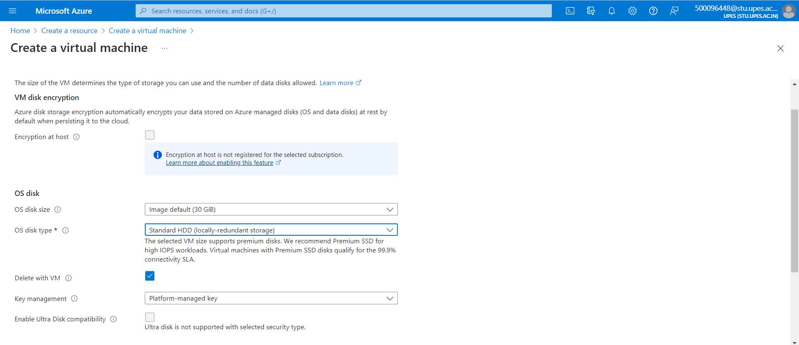

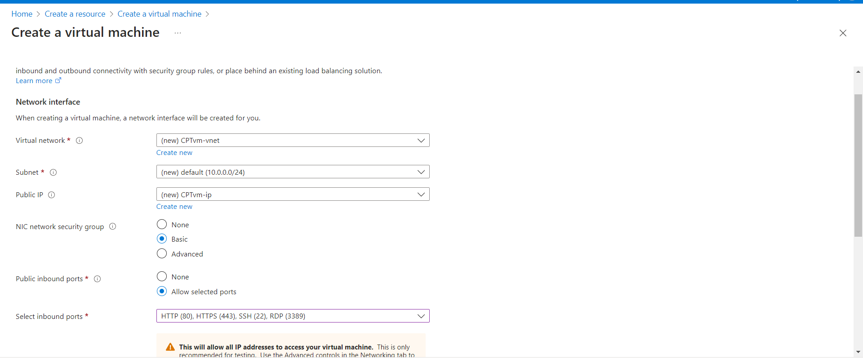

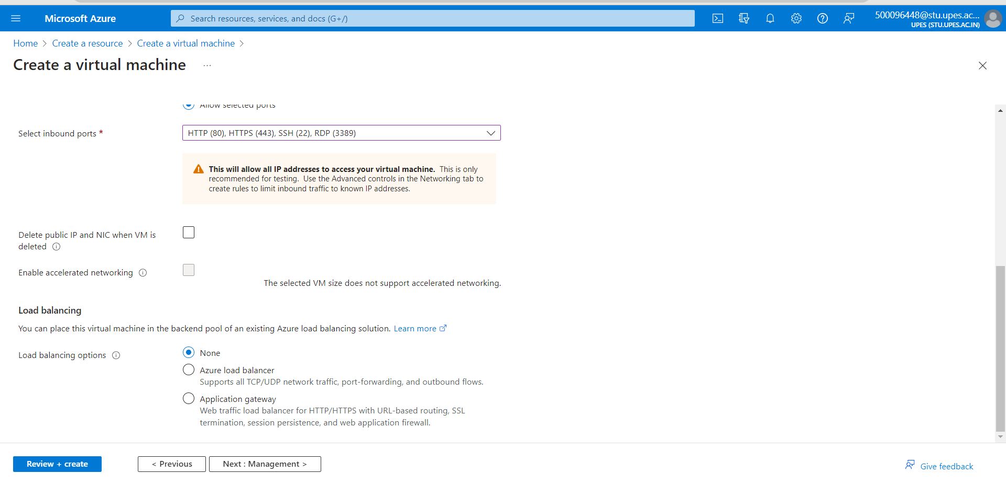

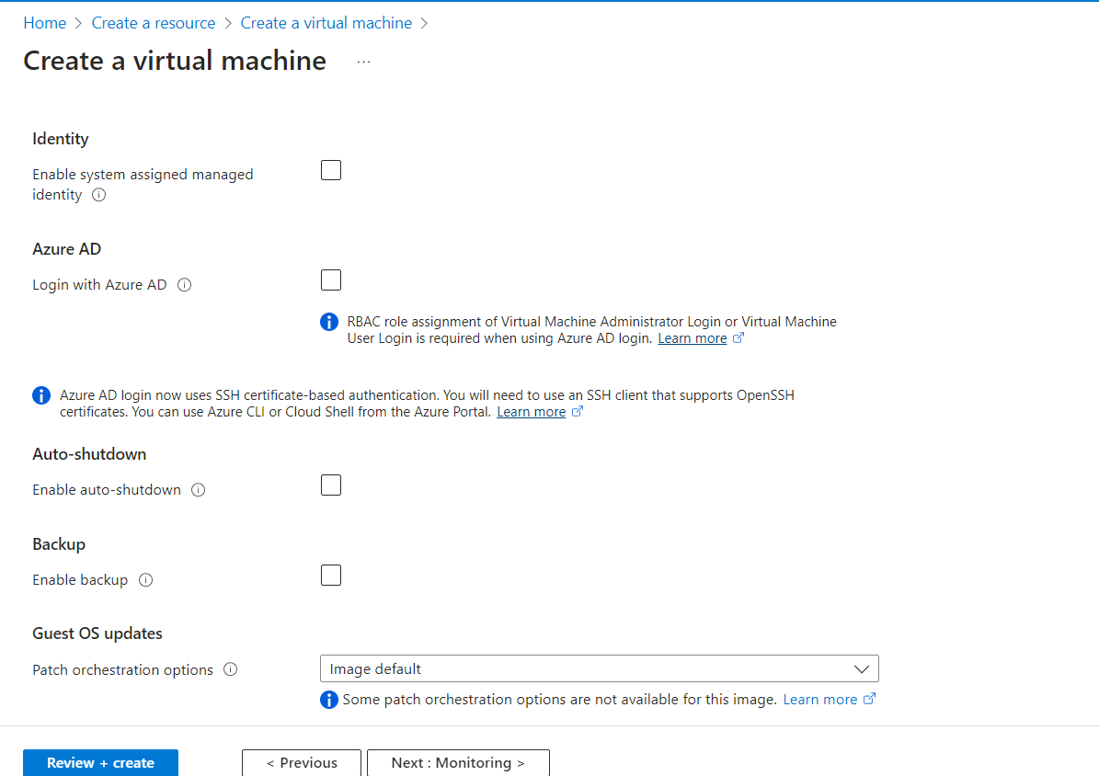

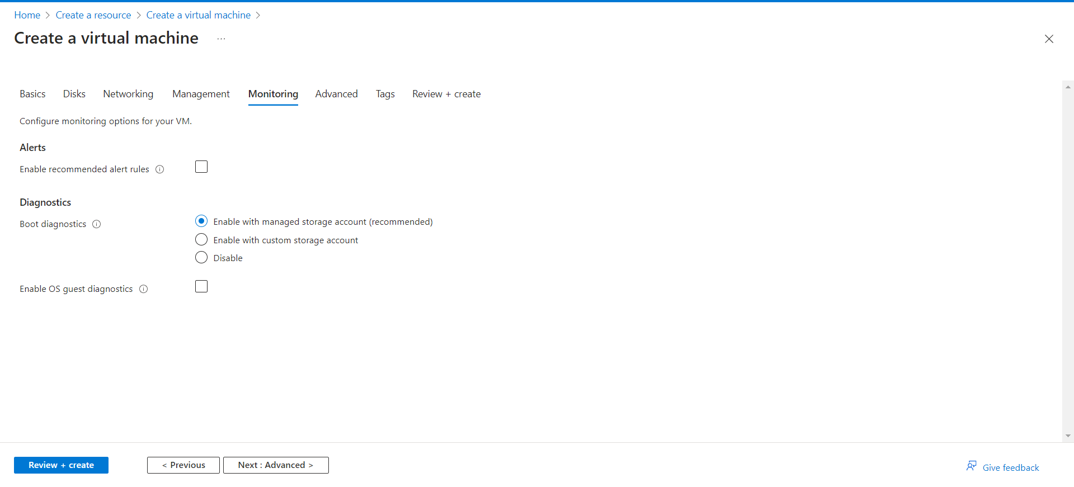

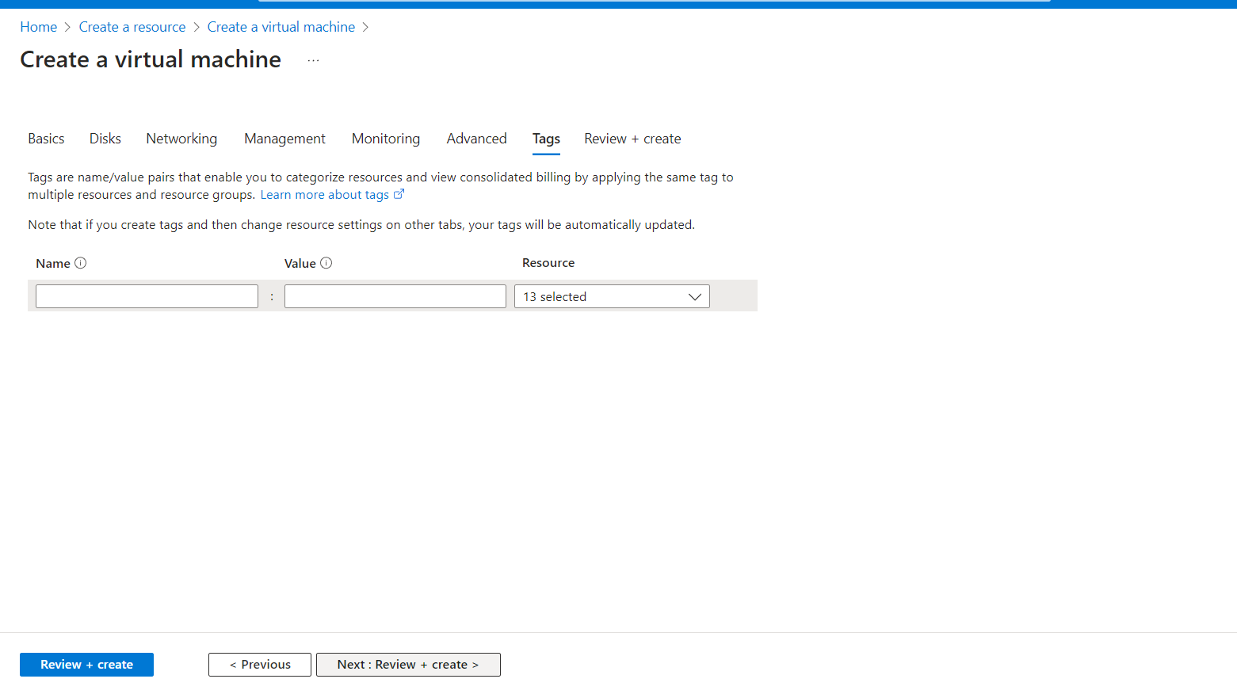

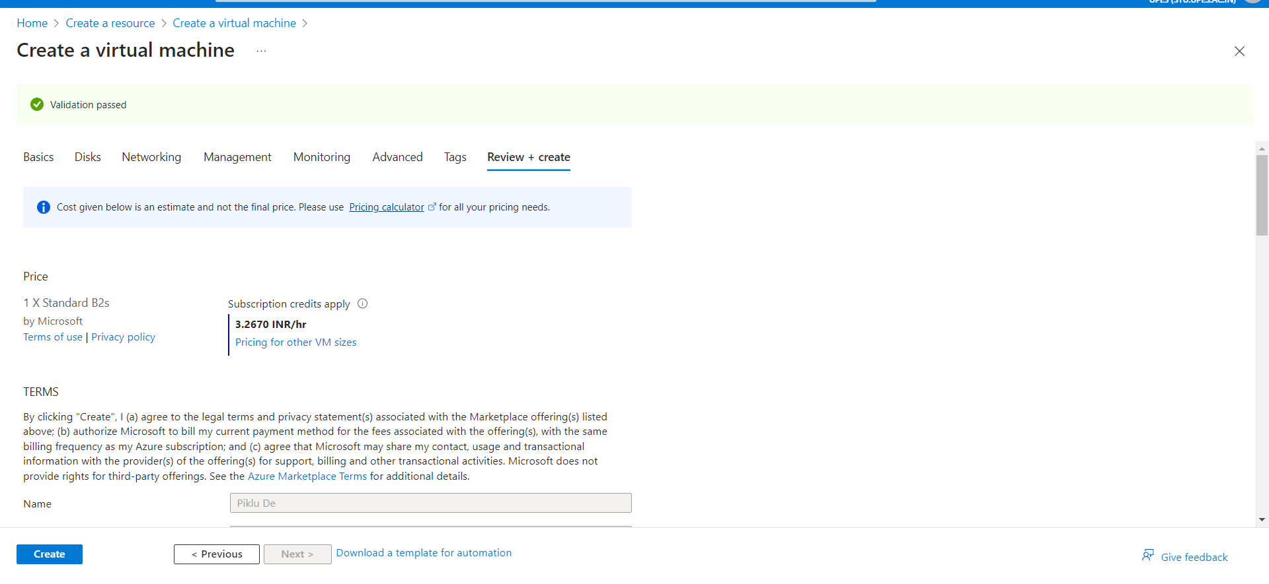



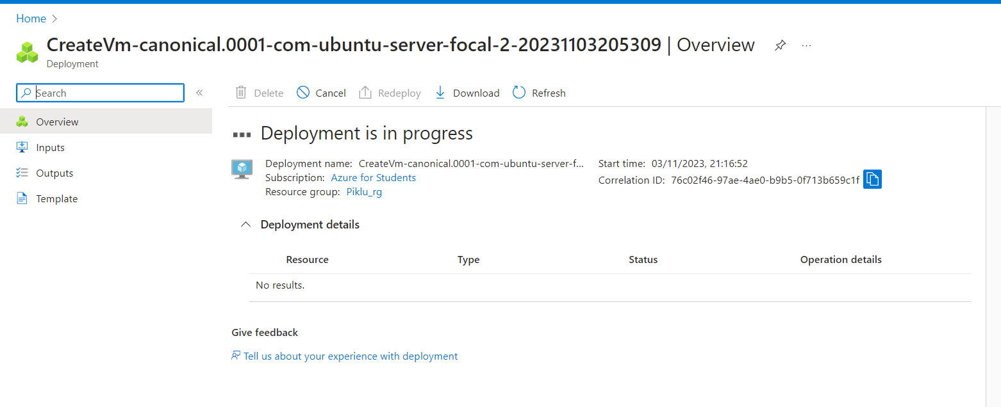

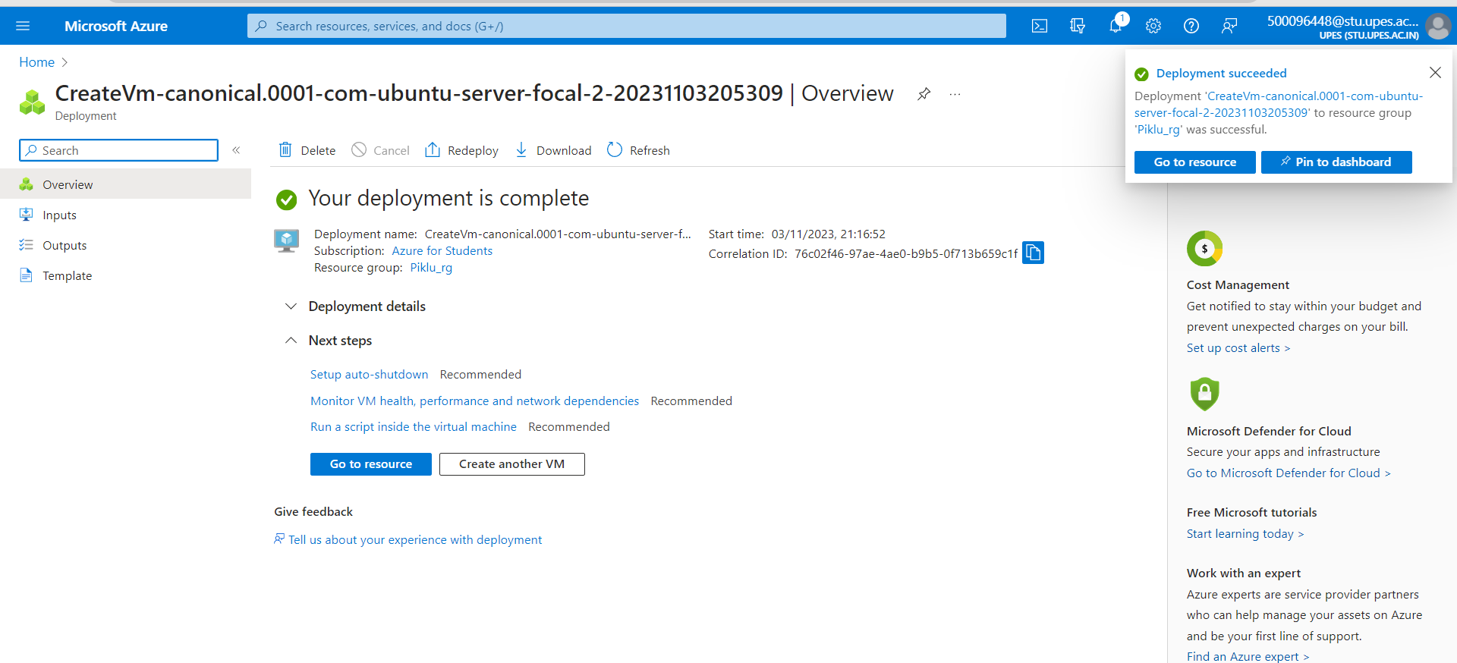

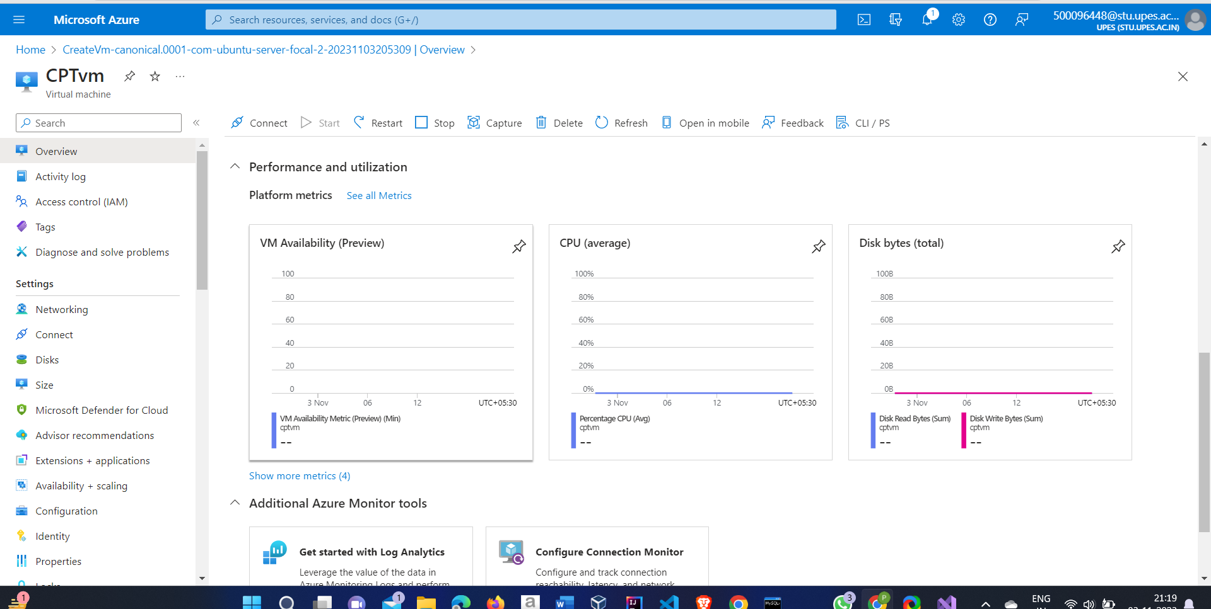

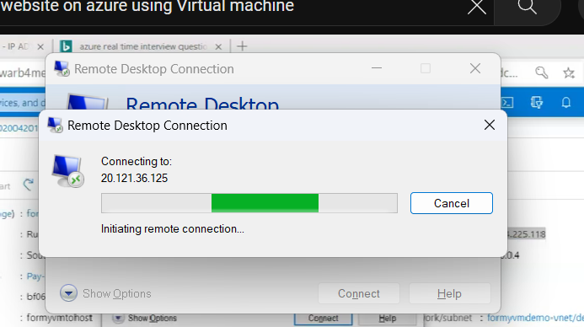

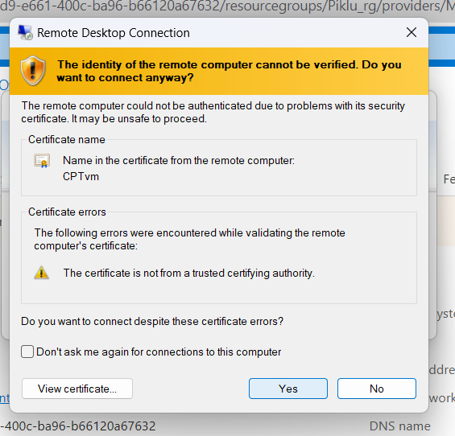

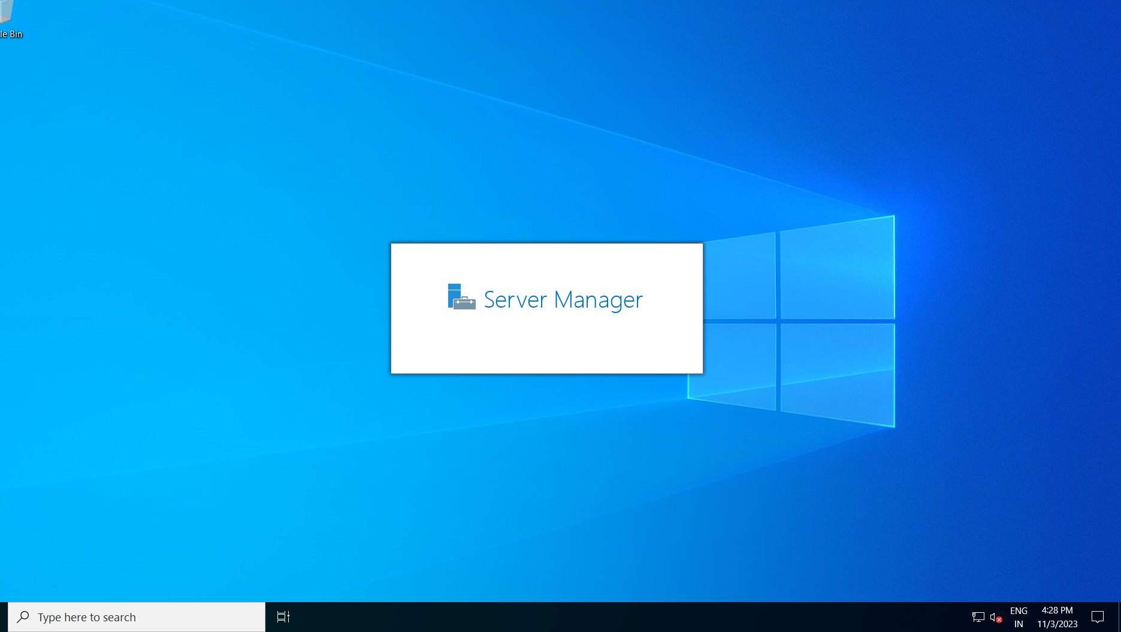

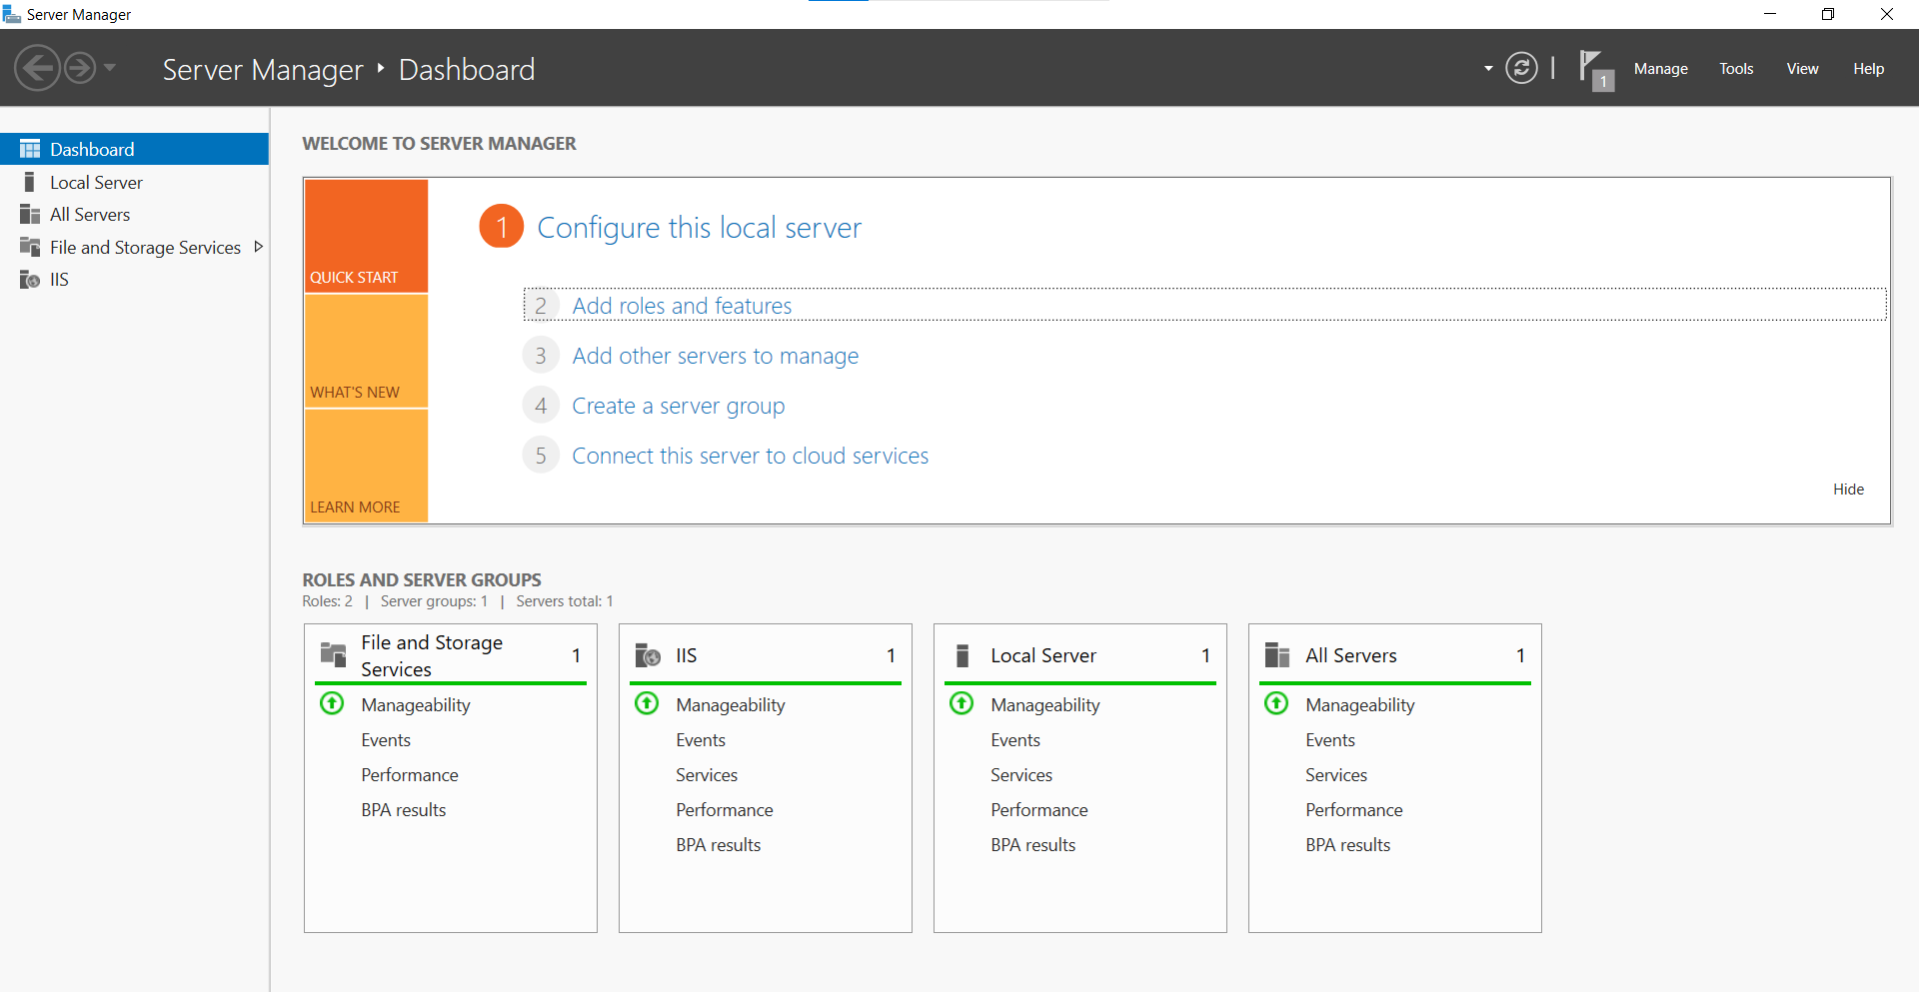

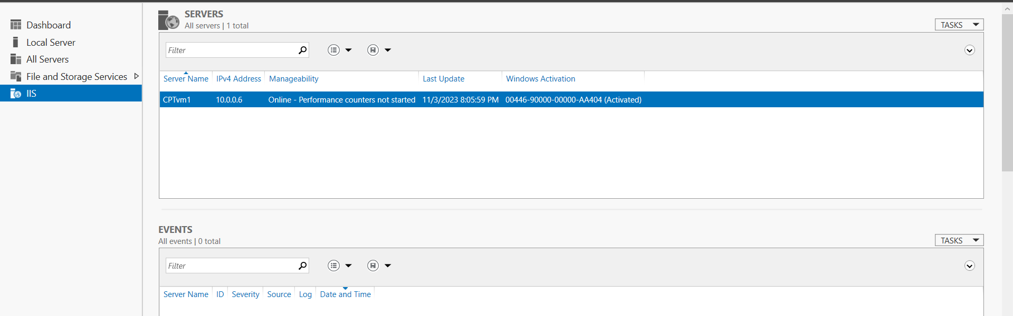

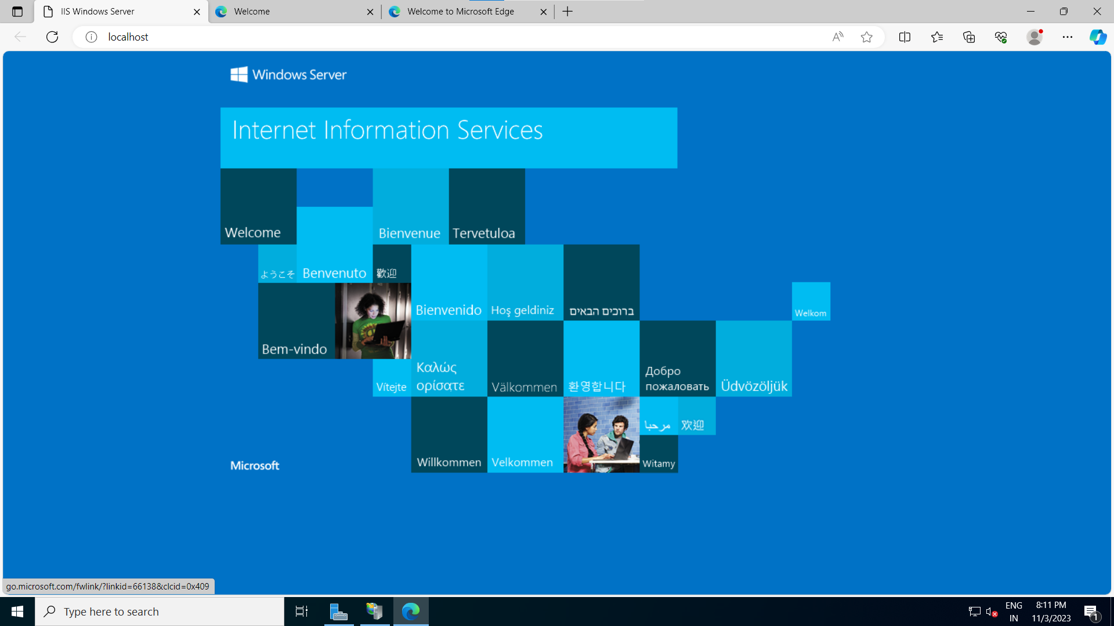

Deploy the website on outside

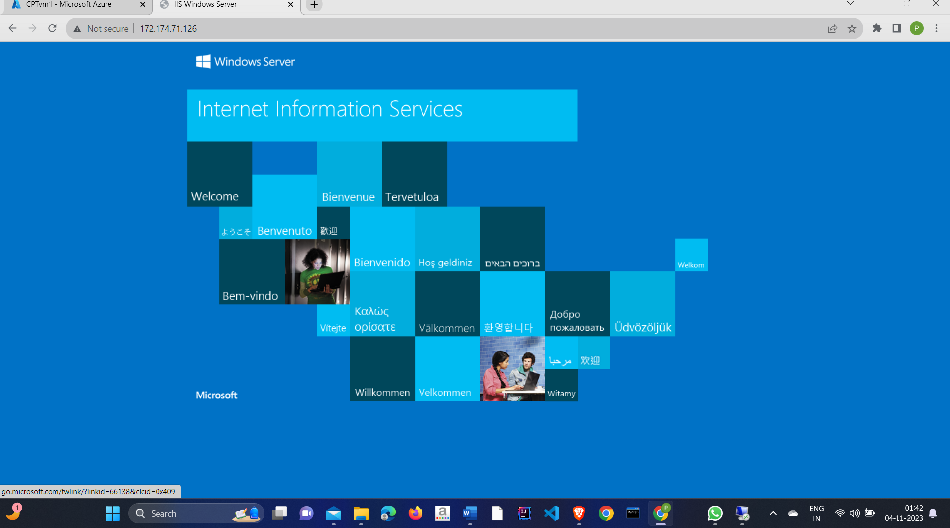

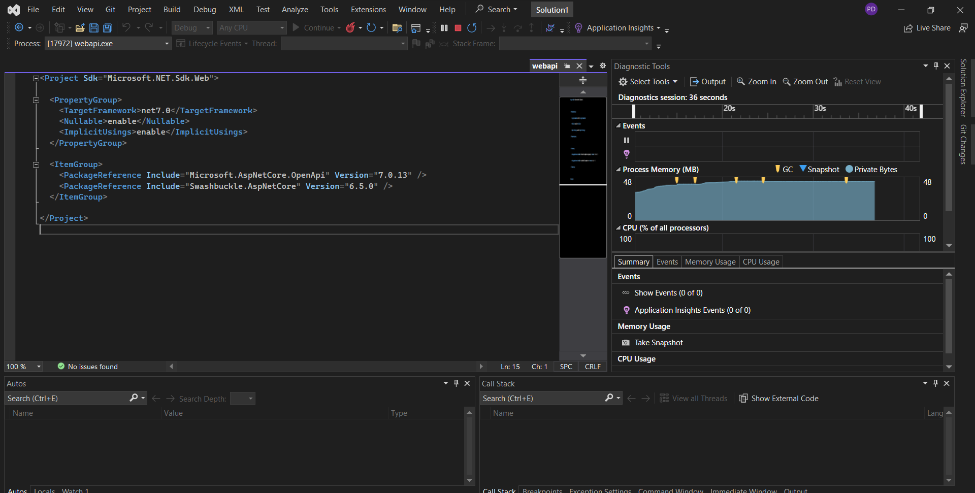

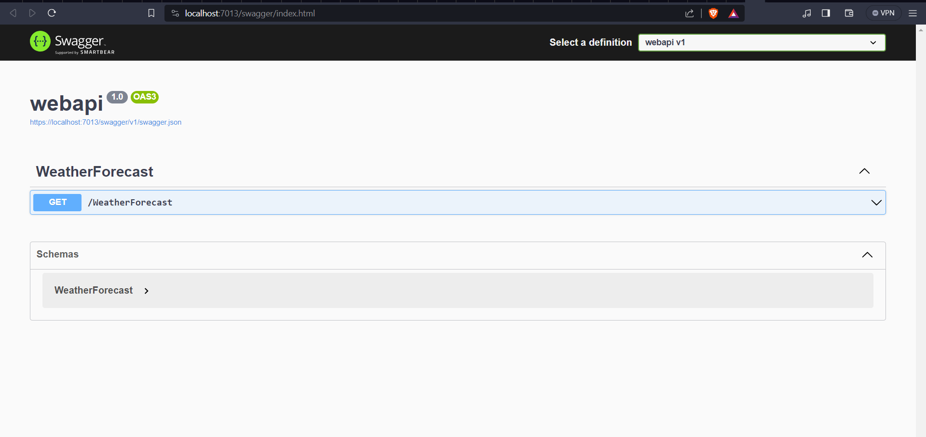

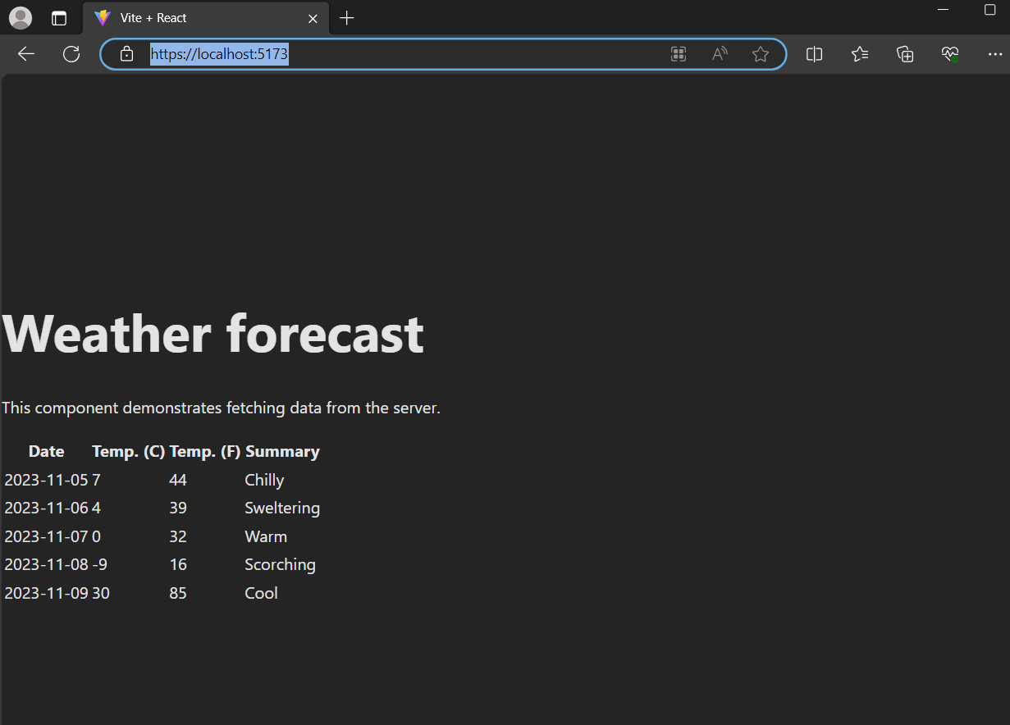

Right Click on the main project and click publish button after that choose the target (Azure) than

select Azure Virtual Machine and which you created

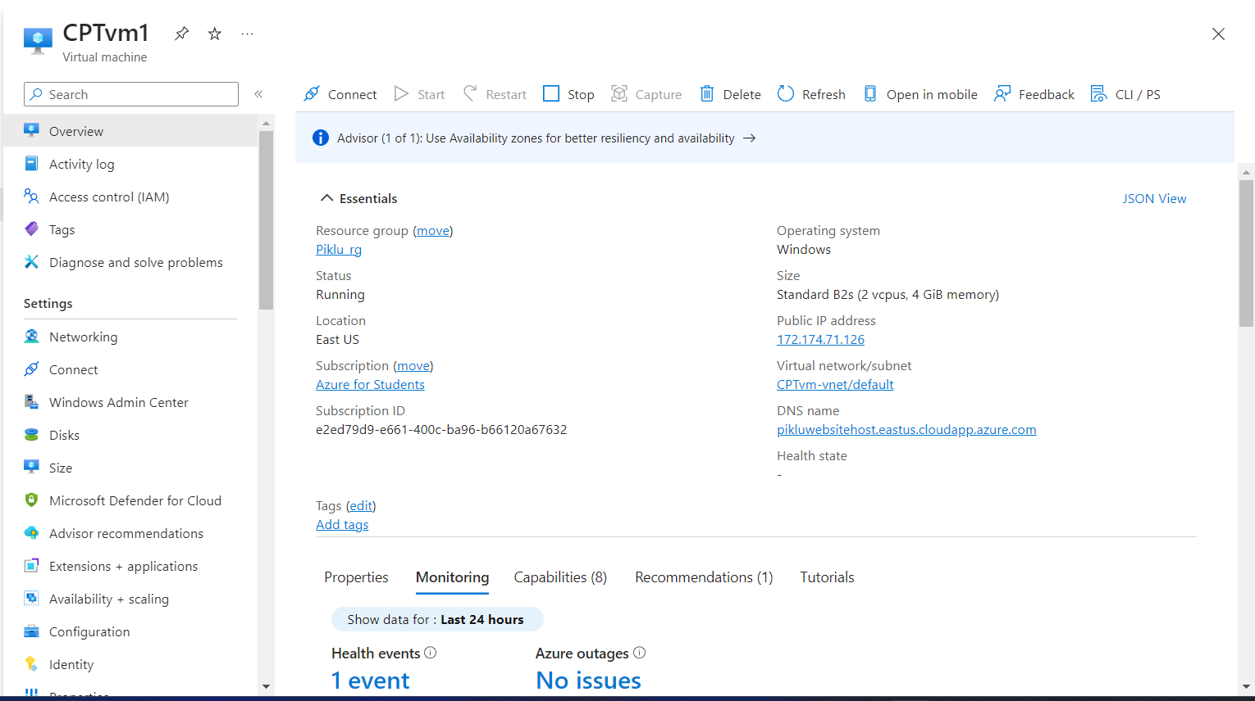

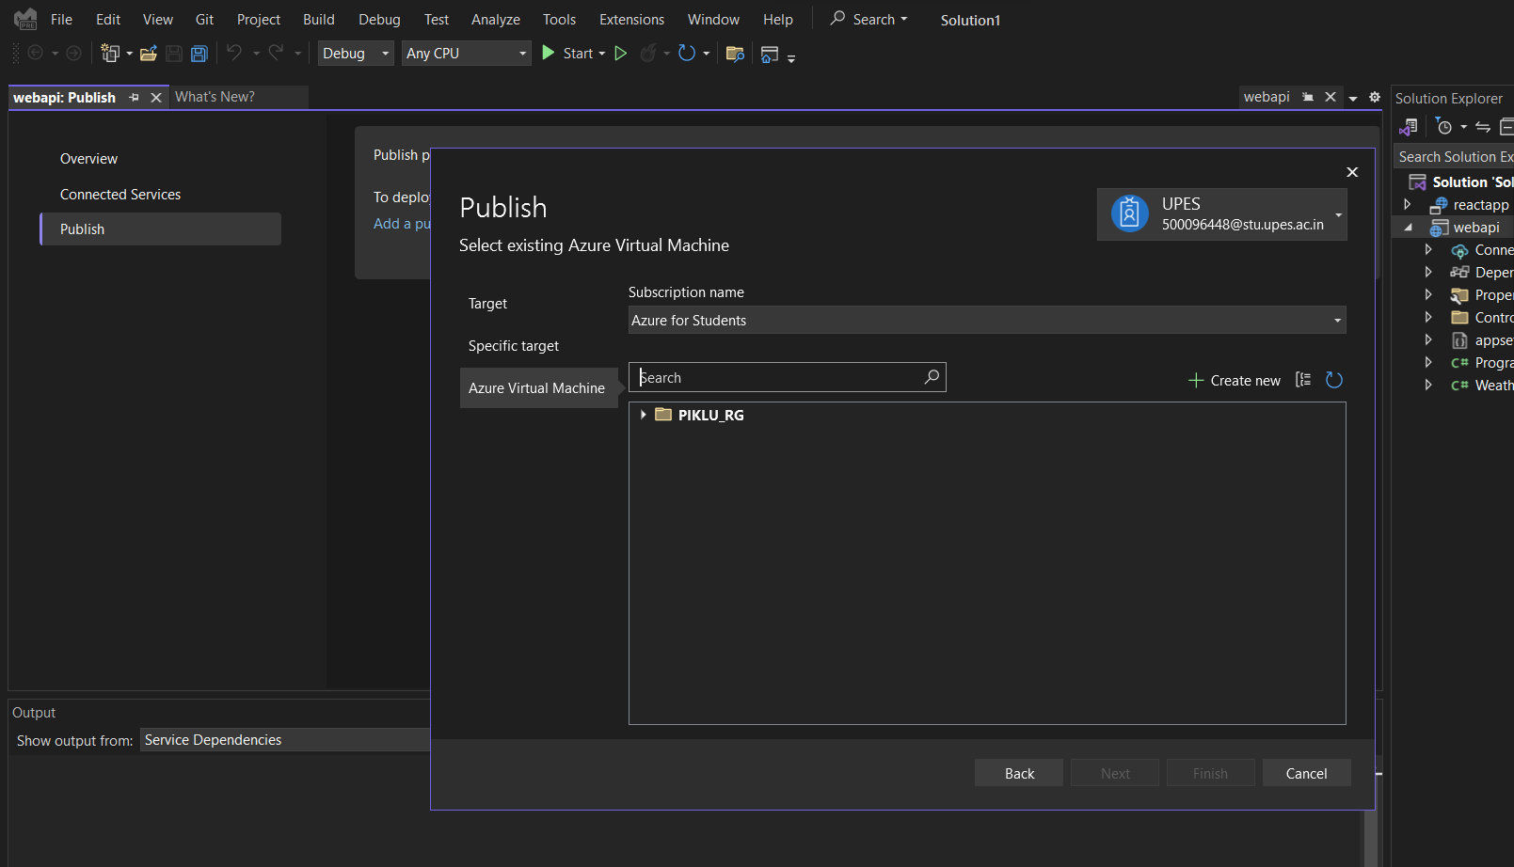

Go to azure portal and add inbound rule

And go to remote desktop and click server manager -> dashborad-> change webserver configuration (enable Manager server)

Next go to local server on remote desktop change the IE enhanced security configuration Administrator and user option disable

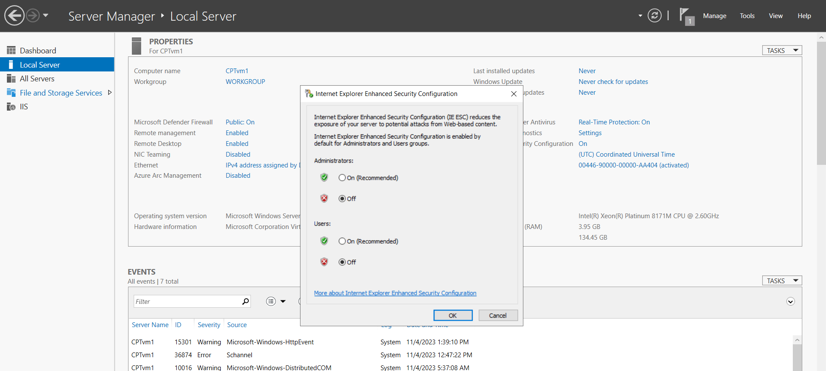

Configure the DNS name

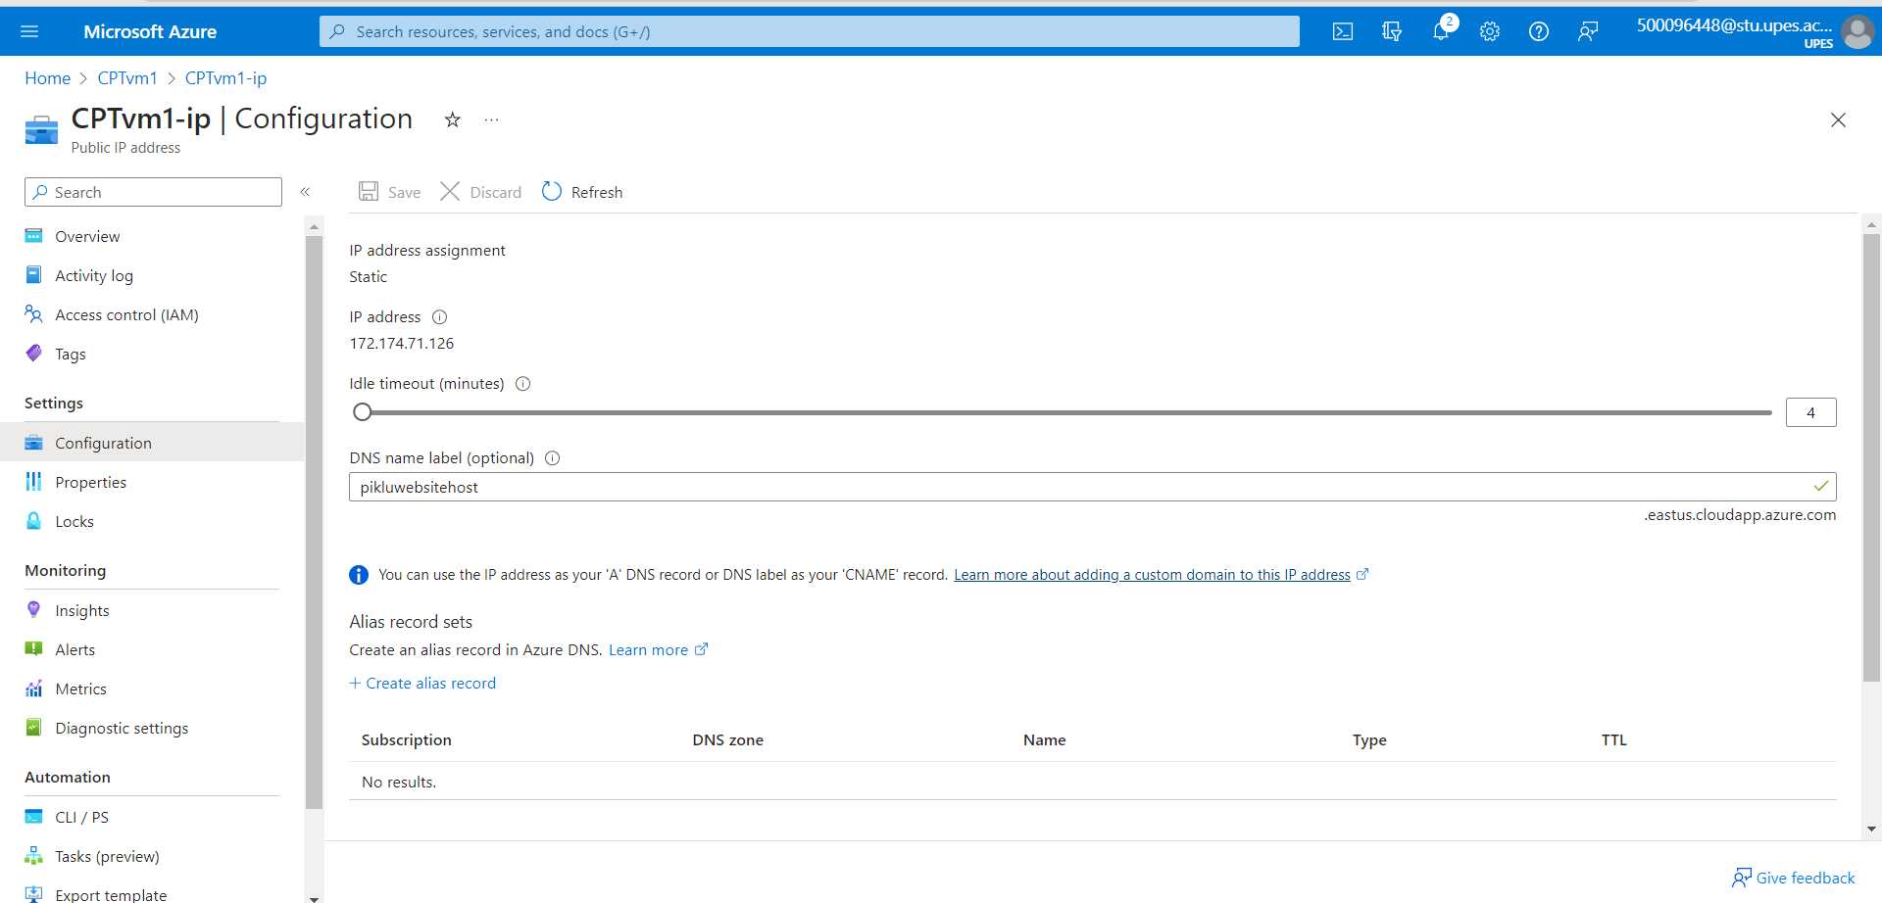

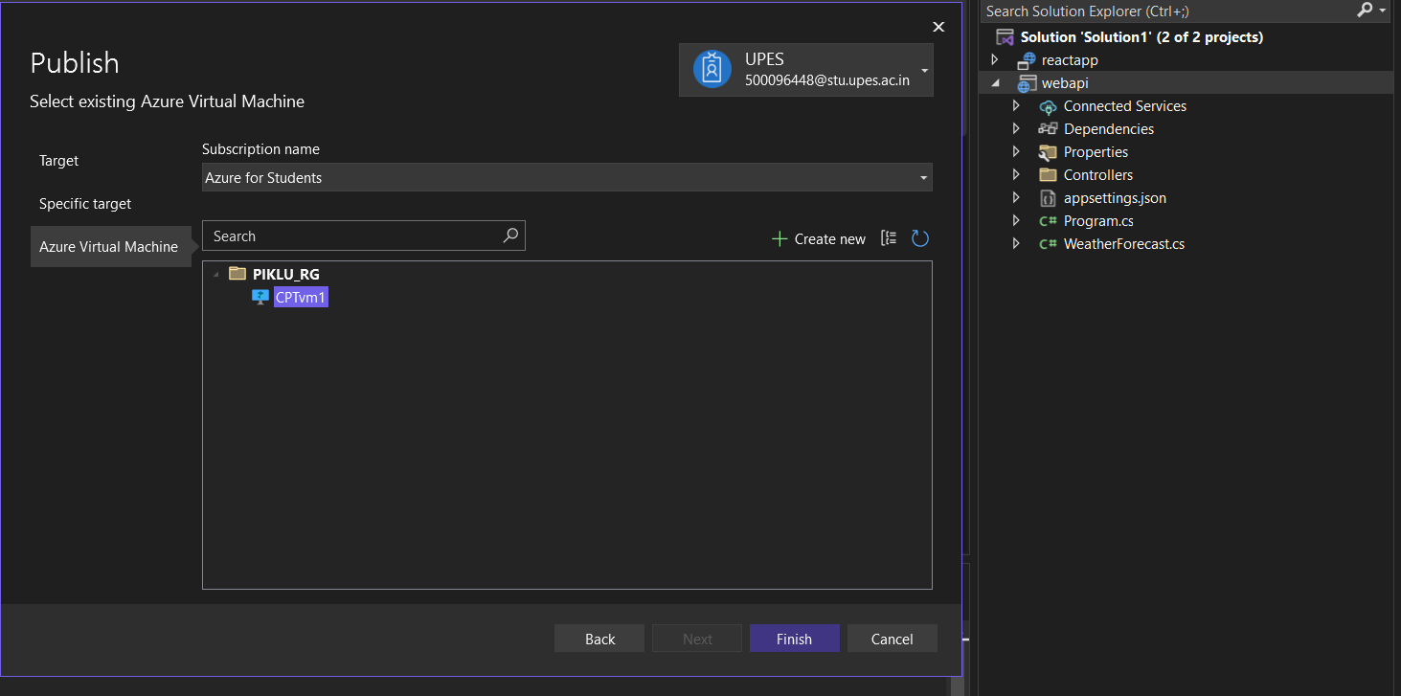

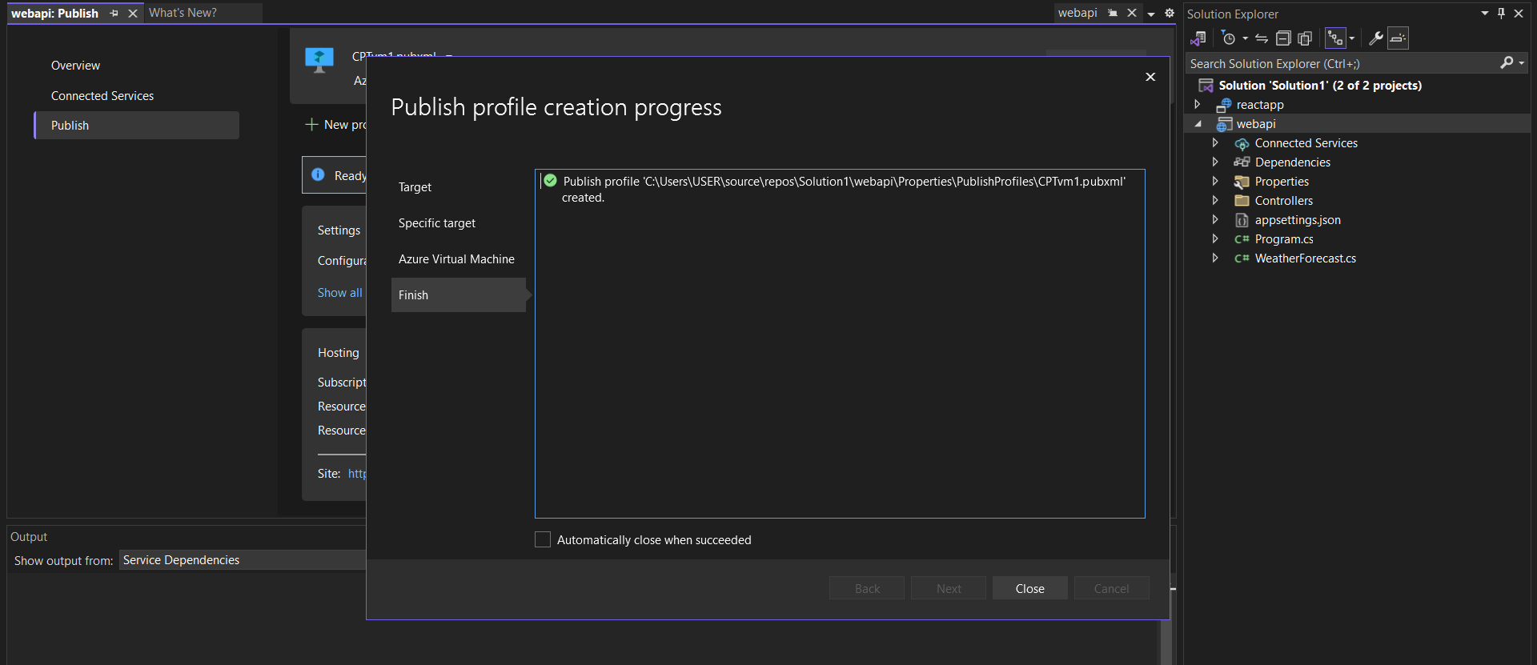

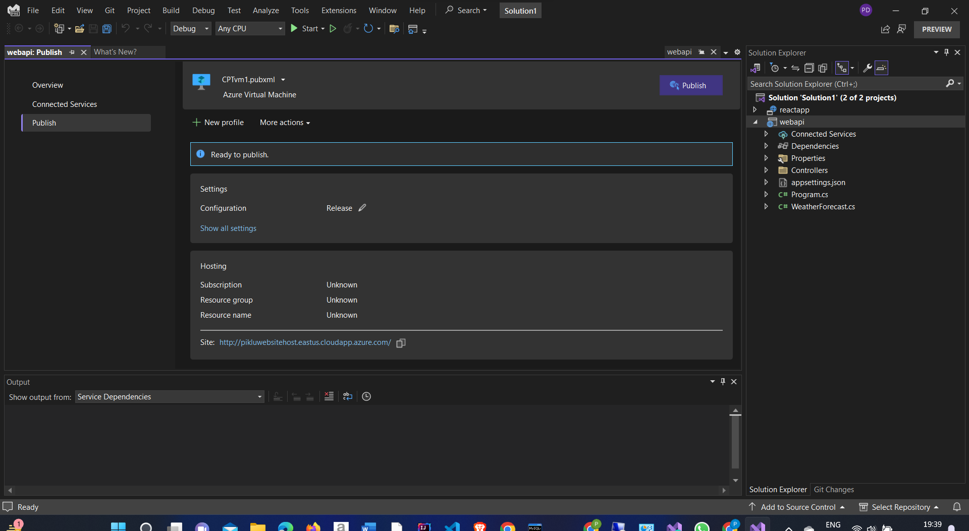

Before publishing the website then the

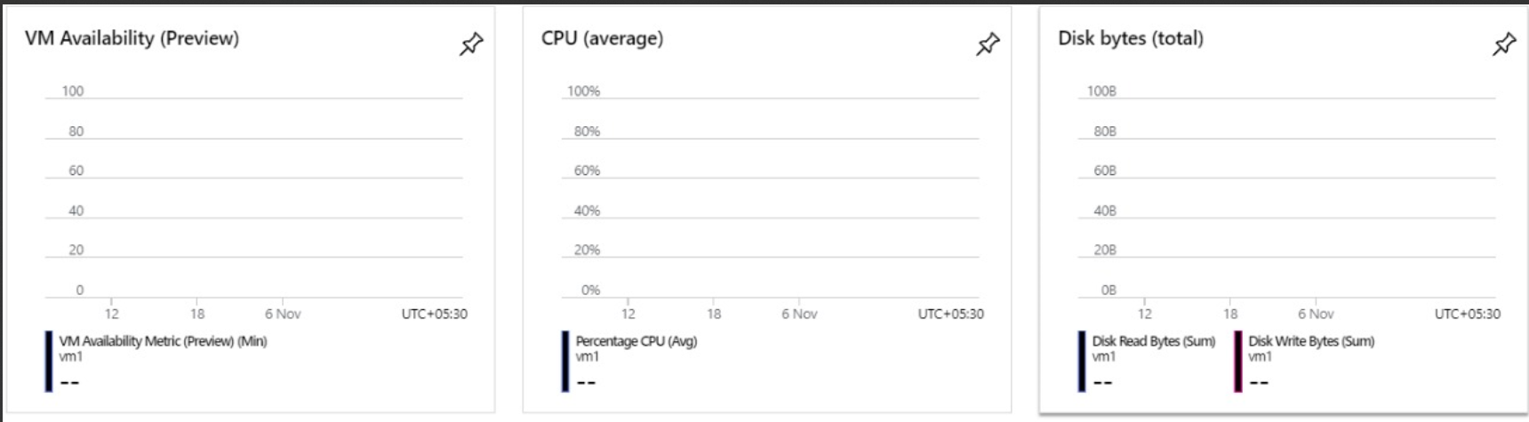

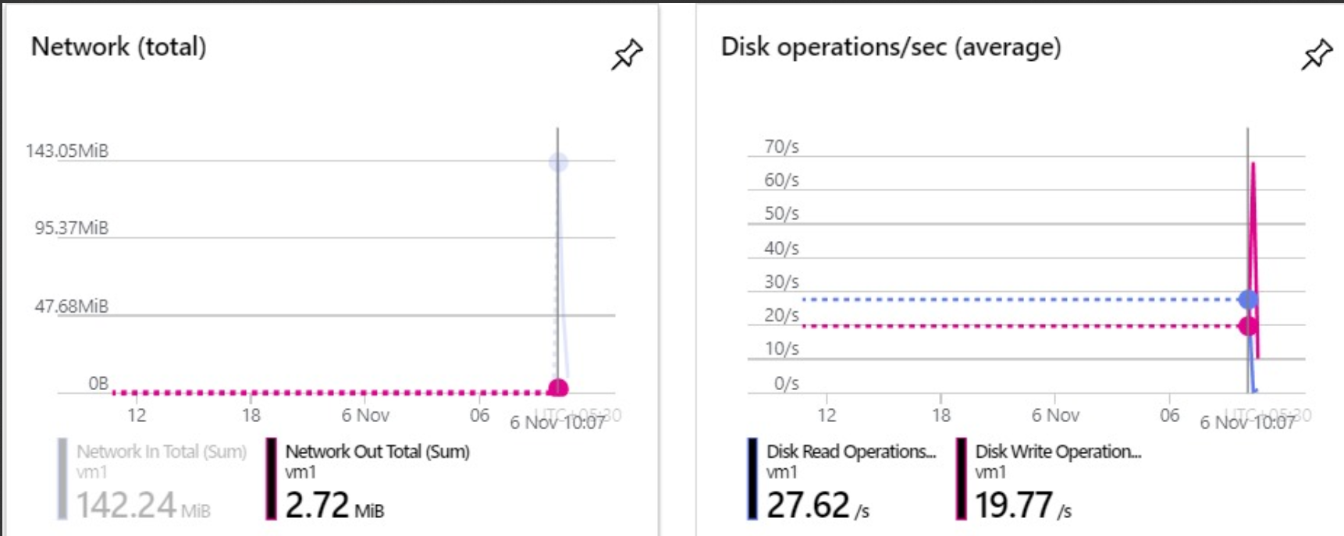

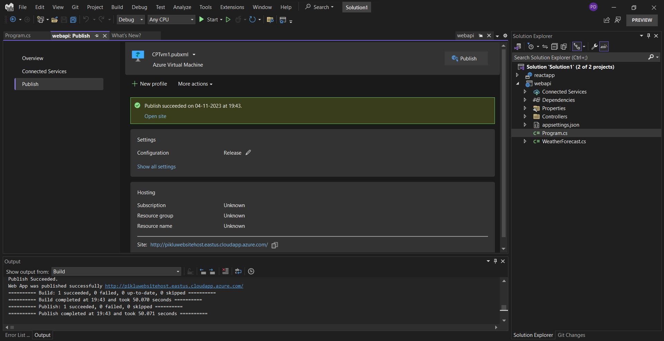

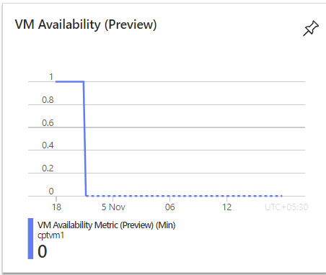

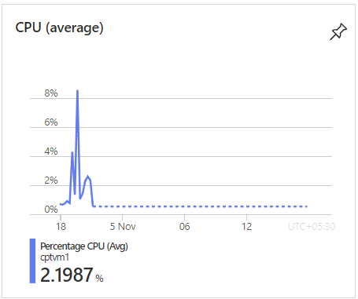

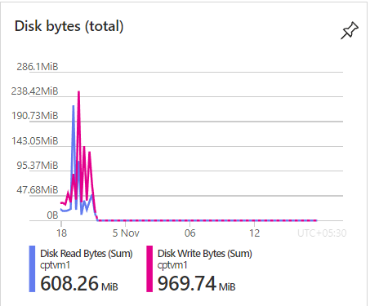

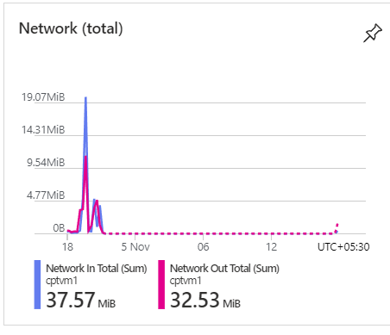

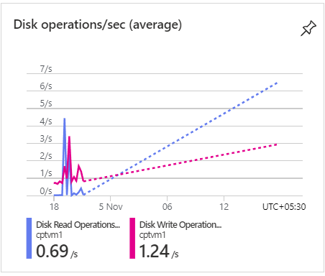

**Response Time**

1. Start Time (t1): Note the time when the request is initiated. This is the starting point.

2. End Time (t2): Note the time when the response is fully received or when the requested operation is completed.

3. Response Time Calculation: Response Time = t2 - t1

**Response Time: minutes 45 seconds**

Deploy On UBUNTU VM:

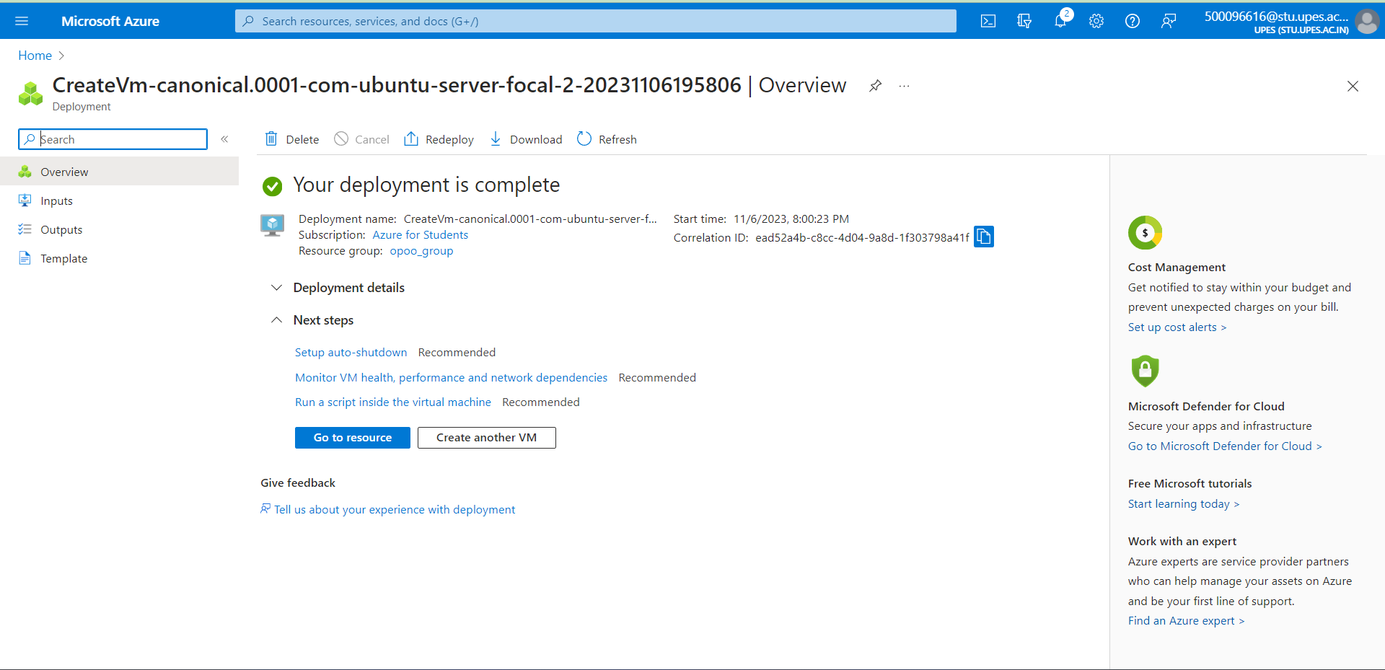

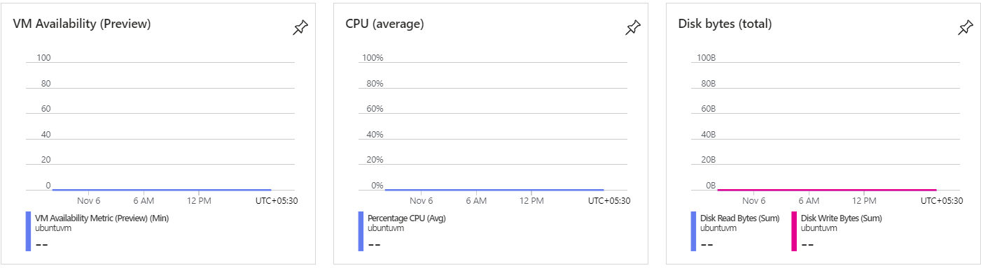

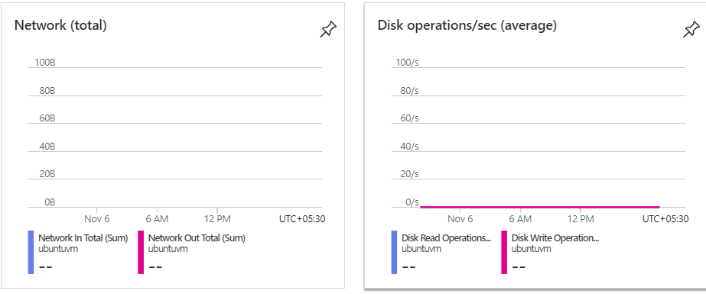

Open to the ssh window:

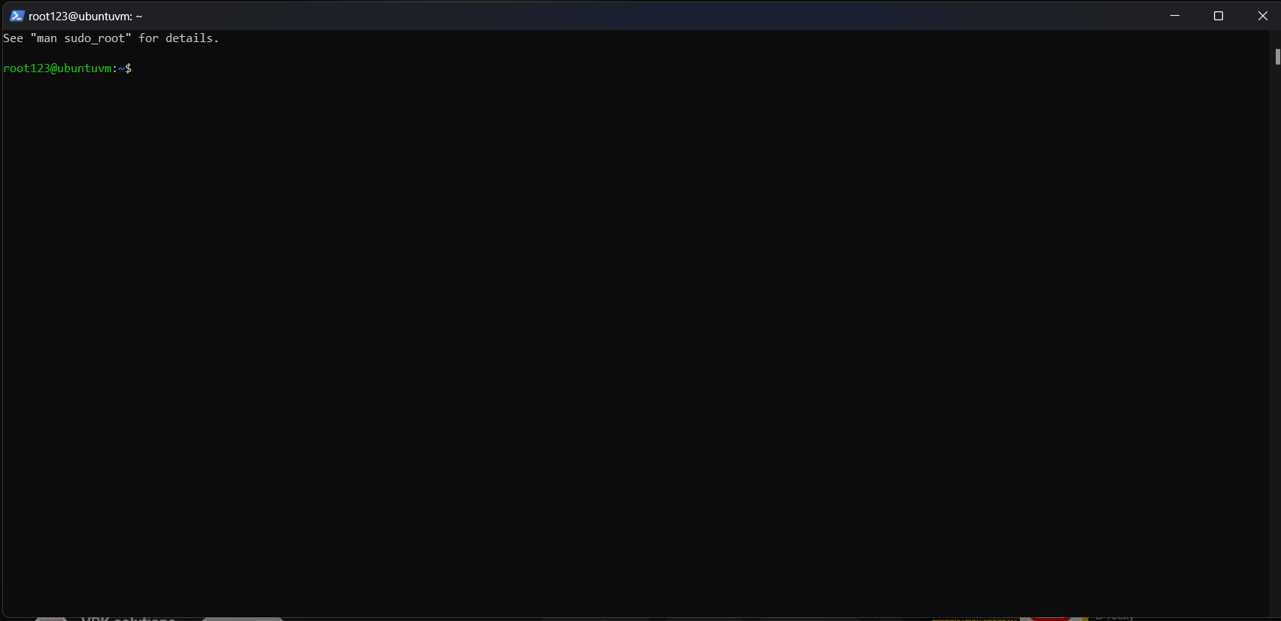

My apache2 server is running

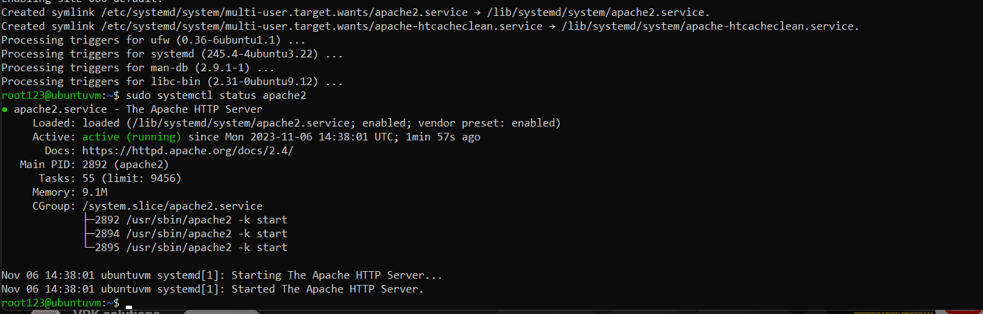

My Azure Ubuntu VM public IP is Fantastically Work:

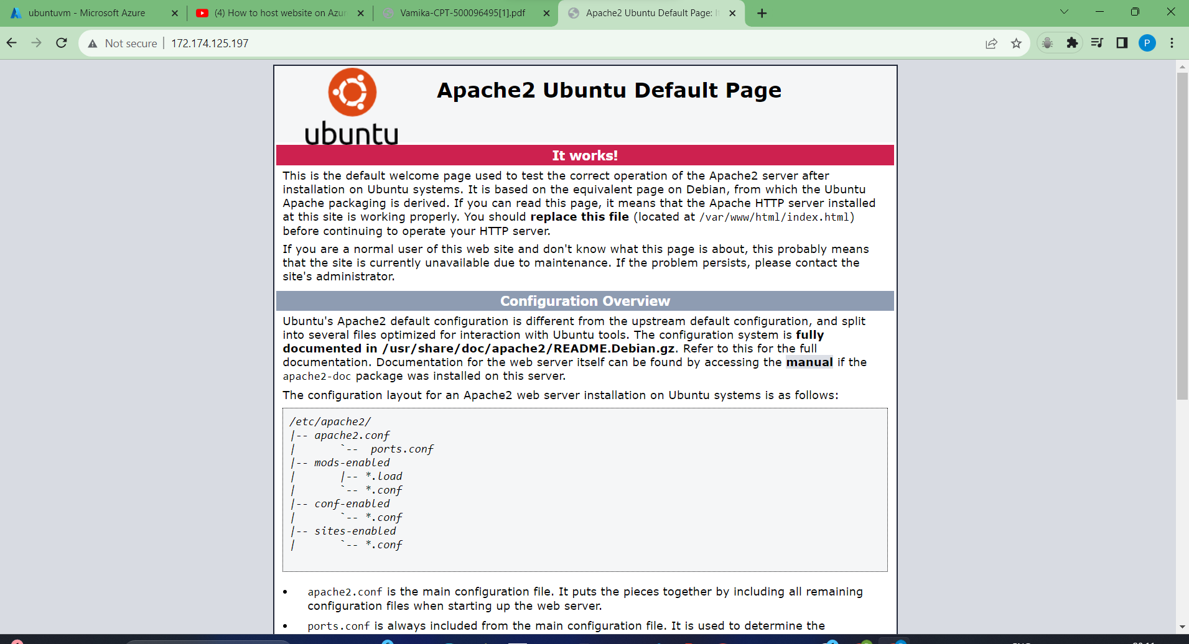

My static website successfully deploys on UBUNTU VM:



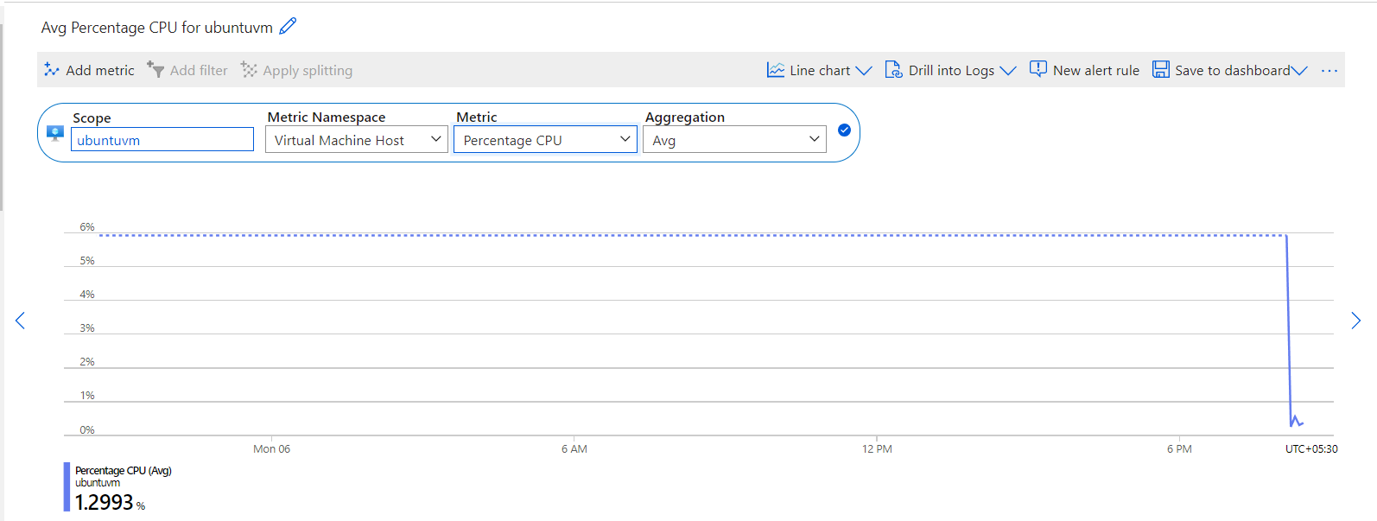

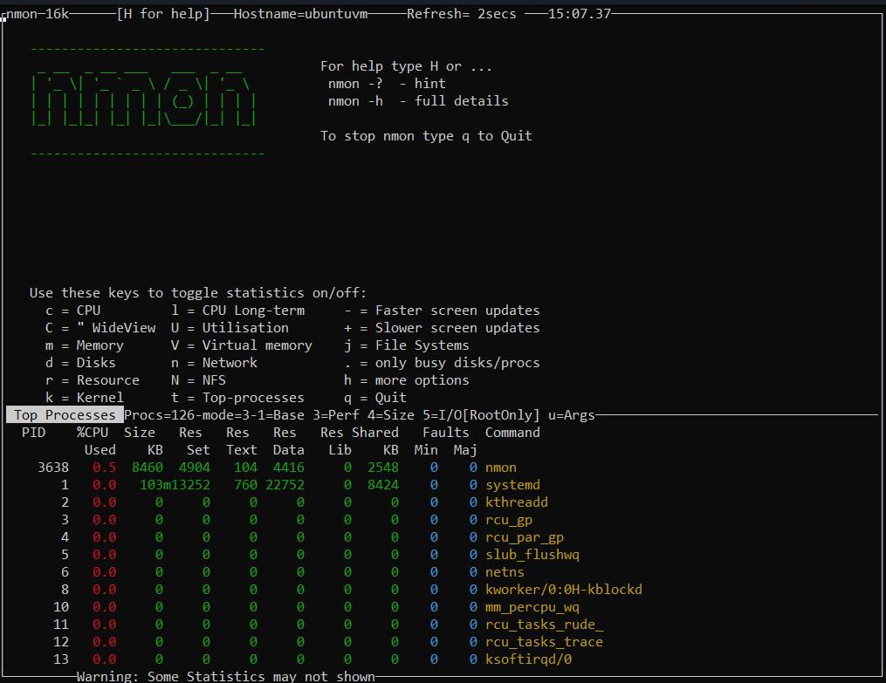

My Memory Utilization, CPU utilization, Network Utilization, Disk Utilization and also Resource Linux and Process

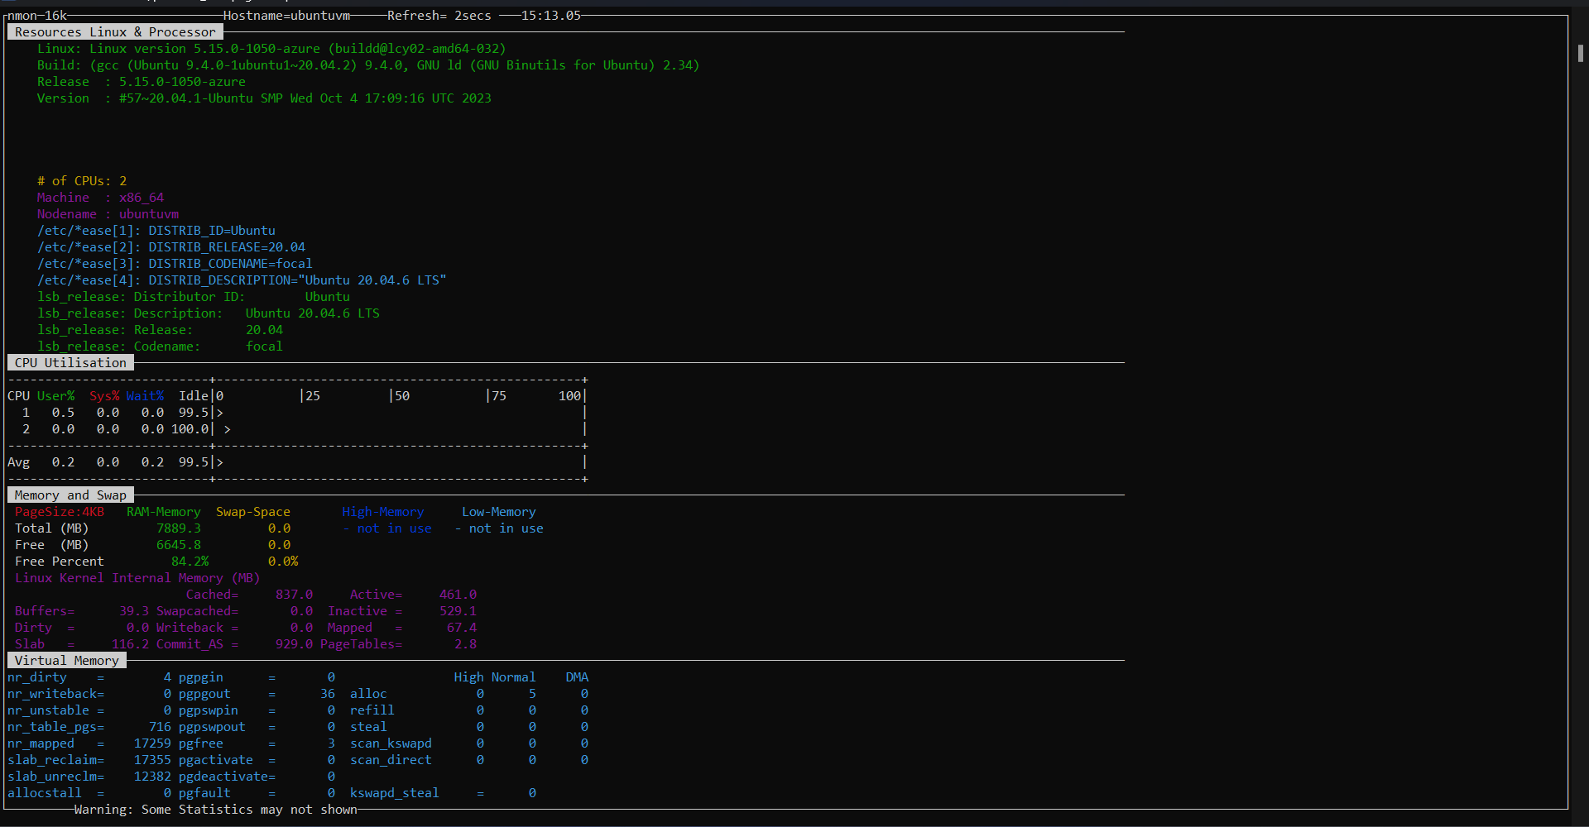

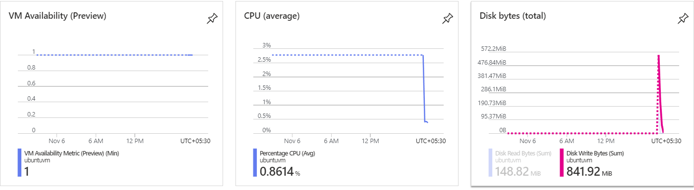

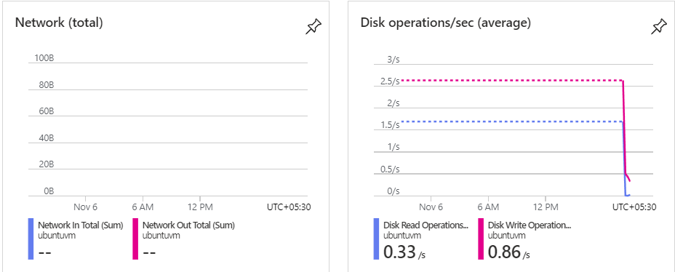

Response Time:

1. Start Time (t1): Note the time when the request is initiated. This is the starting point.

2. End Time (t2): Note the time when the response is fully received or when the requested operation is completed.

3. Response Time Calculation: Response Time = t2 - t1

**Response Time: 11 min 54sec**

Comparison two Virtual Machine

1. Windows VM
2. UBUNTU VM

Windows VM CPU GRAPH:

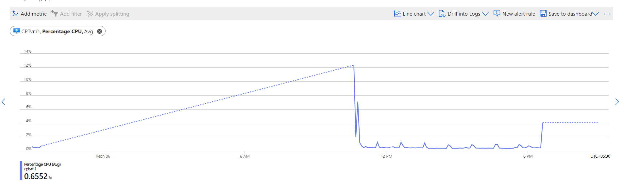

UBUNTU VM CPU GRAPH:

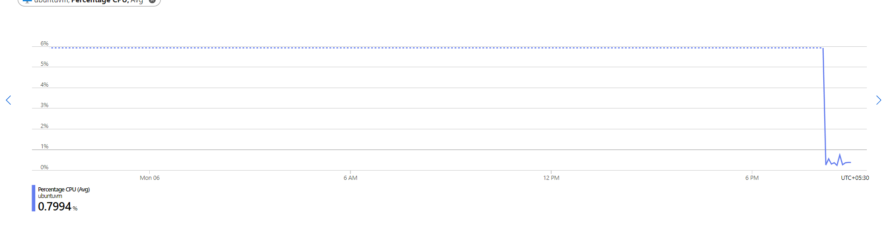

Windows DISK Bytes:

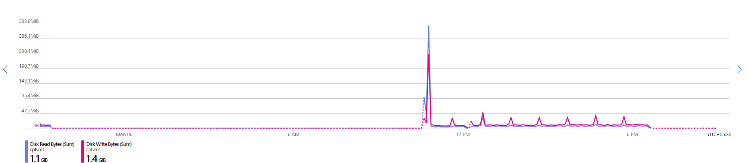

UBUNTU Disk Bytes:

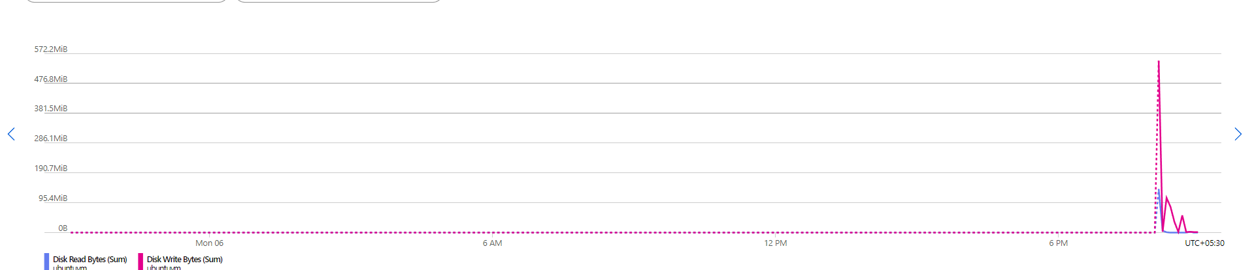

Network For windows:

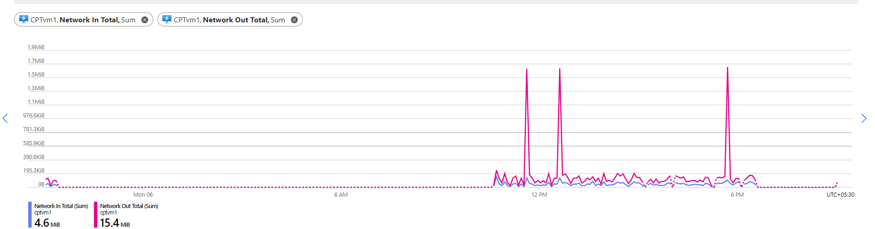

Network For UBUNTU:

VM AVAILITY FOR WINDOWS:

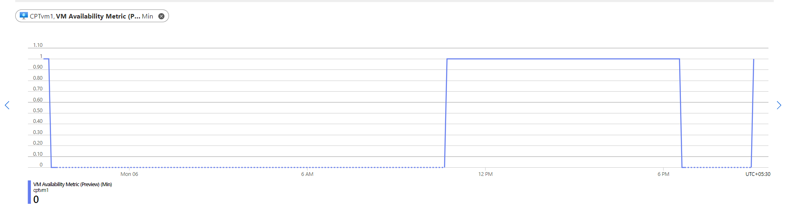

VM AVAILIABILITY FOR UBUNTU:

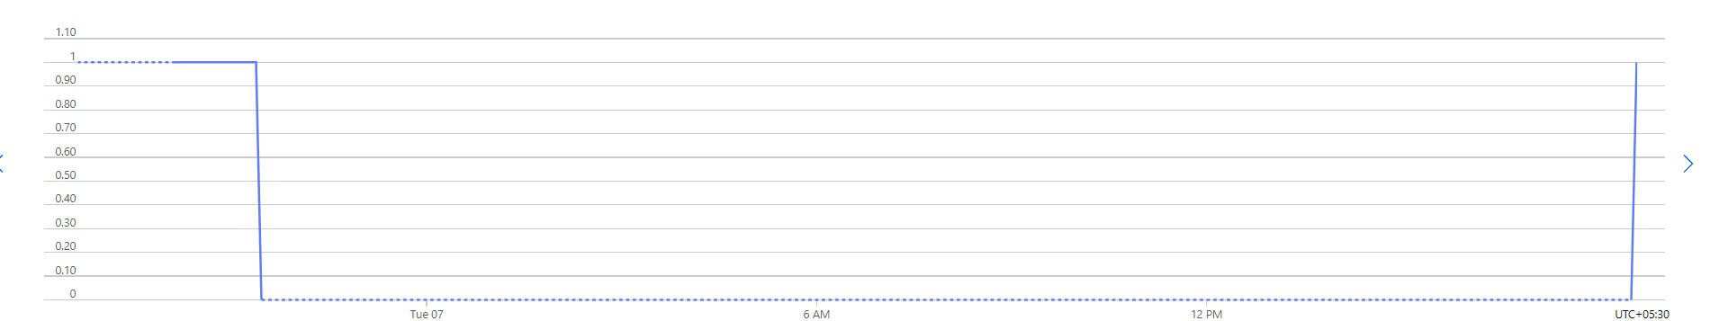

DISK OPERATION FOR WINDOWS:

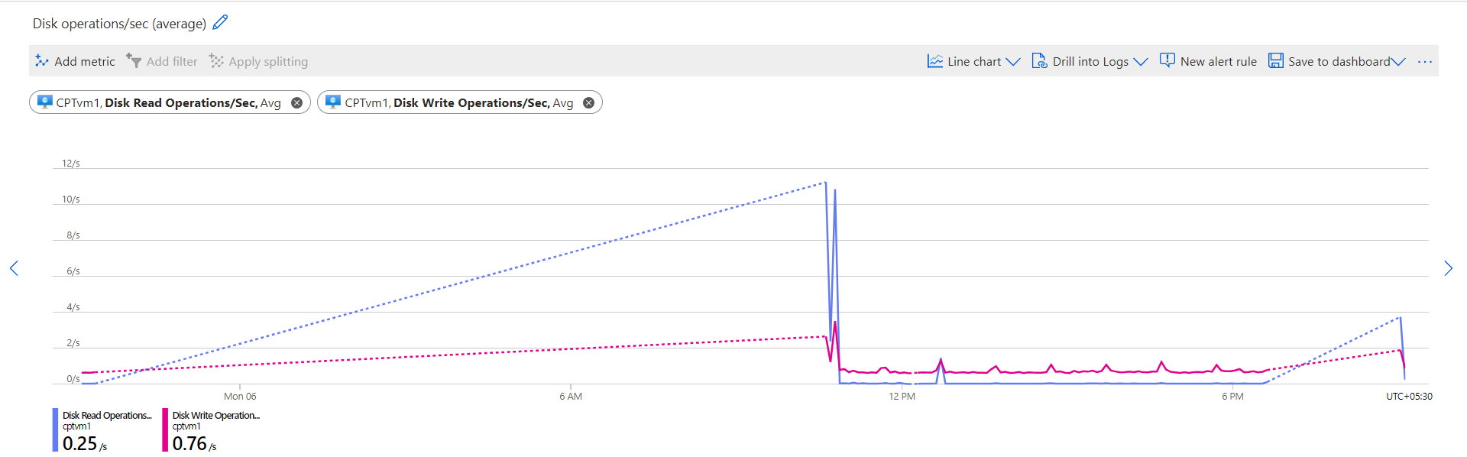

DISK OPERATION FOR UBUNTU:

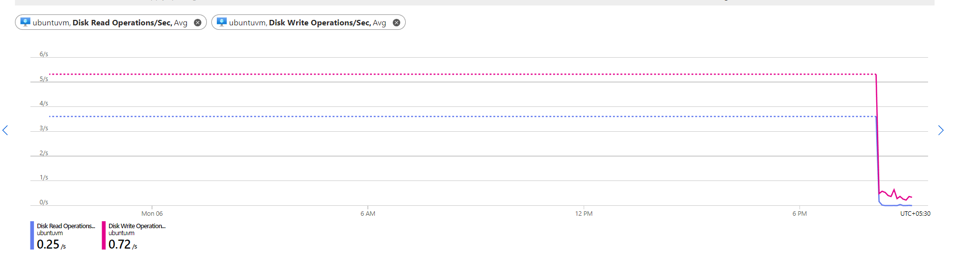

CONCLUSION:

The decision between Windows and Linux for virtual machines (VMs) and their corresponding response times is based on a number of variables, such as your particular use case, your needs, and your level of experience with the operating systems. It is possible to optimize Windows and Linux for performance, but the best option can be different

Firstly, Cost:

Linux is a popular choice for virtual machines (VMs) in cloud environments since it is open-source and can have cheaper licensing than Windows. Should cost be a major consideration, this could affect your choice.

Secondly, Administration and Management:

Select an operating system whose management and administration your team is accustomed to. If your team is proficient in Linux, sticking with Linux virtual machines can be more effective. While Windows and Linux both have strong security capabilities, there are differences in the security environment.

In conclusion, it is impossible to say with certainty which operating system will respond to virtual machines (VMs) faster: Windows or Linux. The decision is based on your unique requirements and preferences.

Following the two operating systems' tests:

1. Where Response Time is the main component for choose the OS.

Here we can see that our windows response time is Greater than Ubuntu response time (Windows response time is 10 min 23 sec where Ubuntu Response time is 8min 56 sec)

1. Ubuntu Linux systems are renowned for their quick performance because of their minimal weight and effective resource management. They are advantageous for speedy performance since they often have little overhead and are very sensitive.
2. We have observed that Ubuntu uses less CPU power than Windows in both scenarios. Windows may have a tendency to use more CPU resources for its GUI and background services, which could occasionally result in a slightly greater CPU utilization.

Resource Efficiency:

Linux is often seen as a more cost-effective option than Windows due to its lower system requirements and reduced resource consumption, which can lead to improved performance, particularly when using virtual machines with limited resources.

Attached a Load balancer

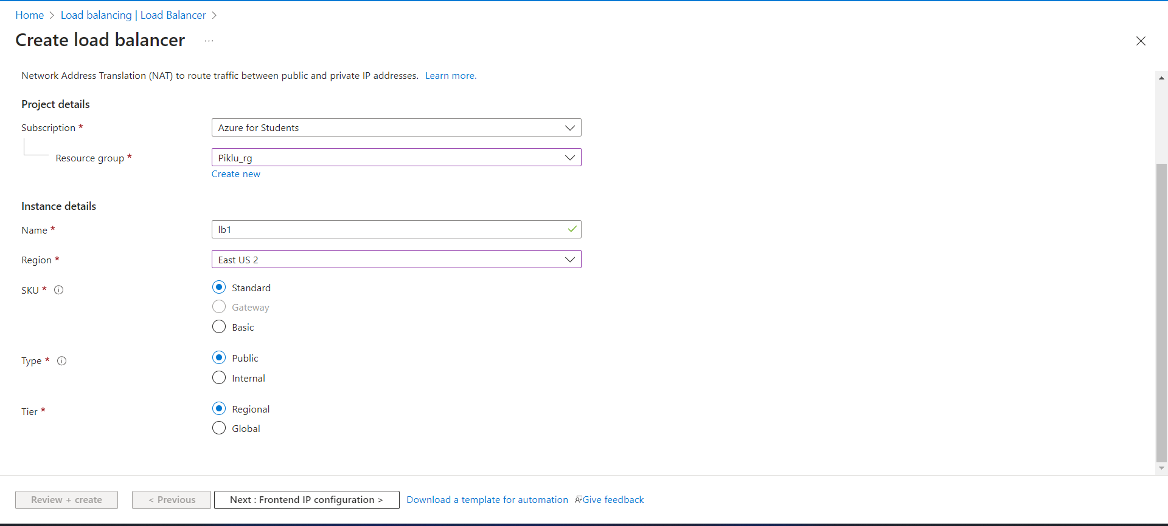

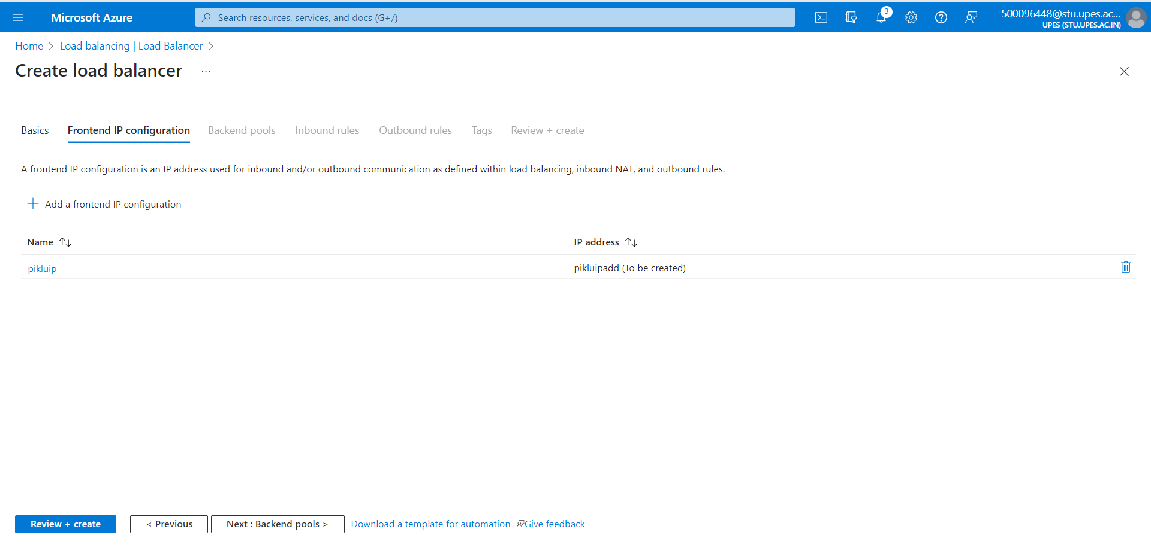

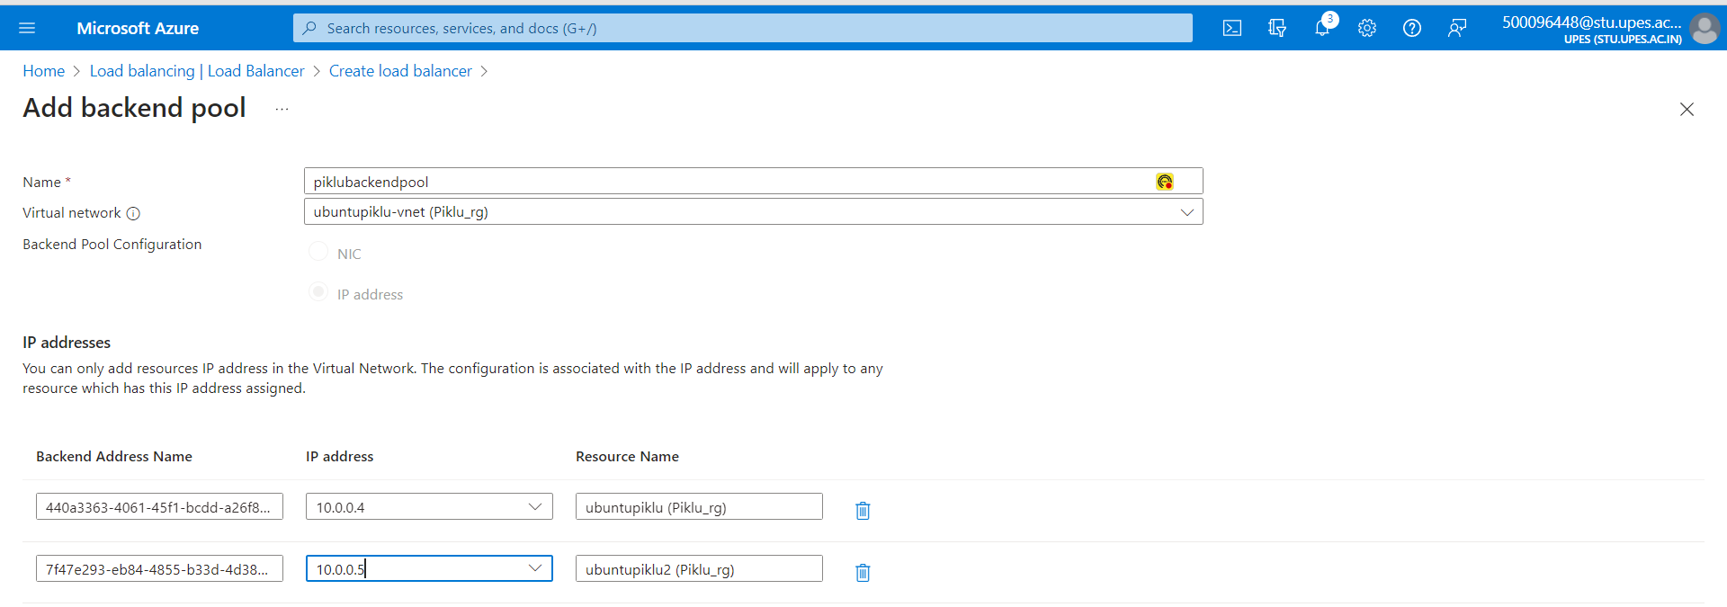

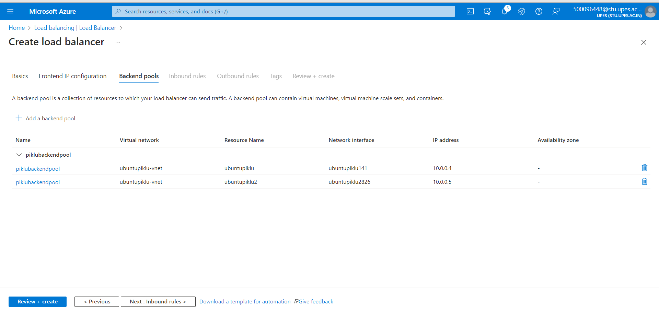

Create a Health Prob

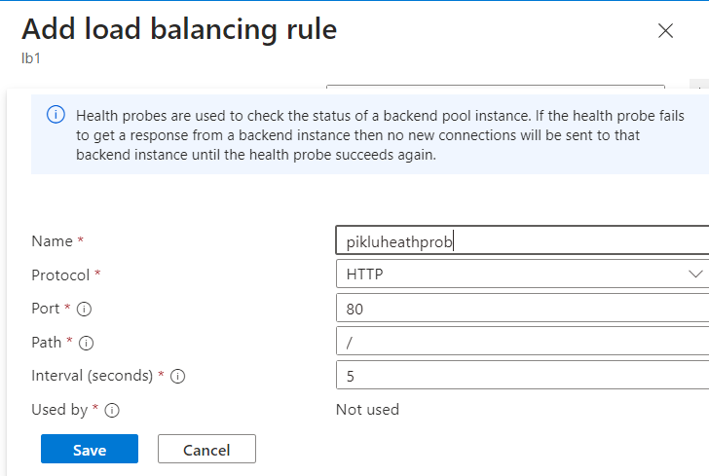

Step: Virtual Machine Scale set

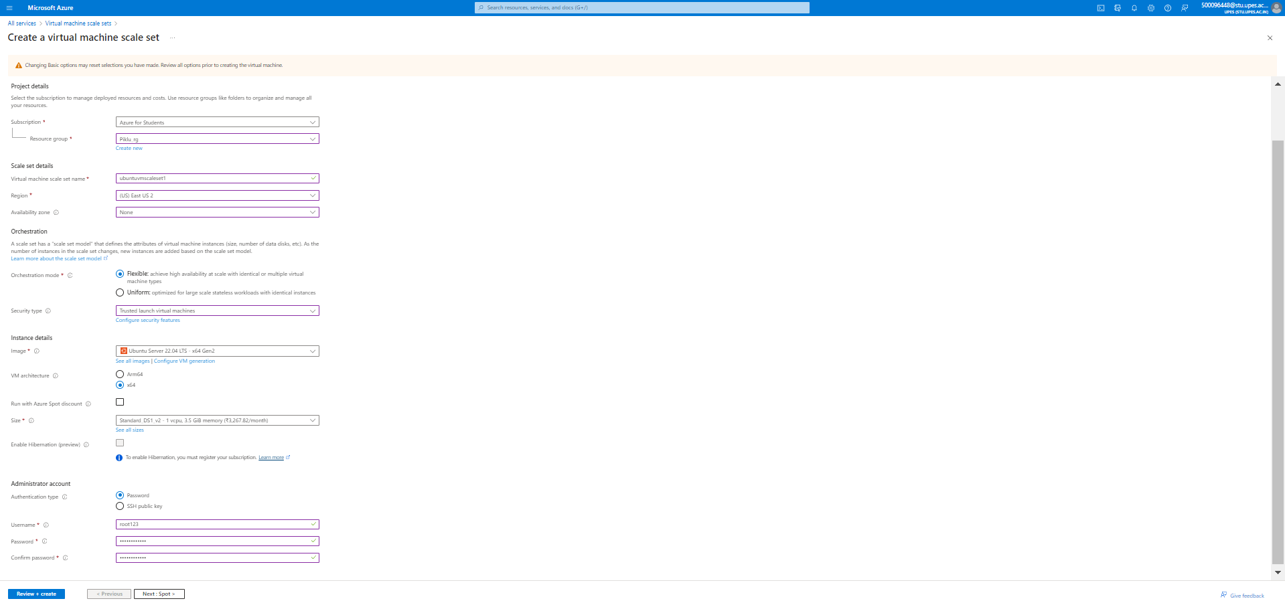

Default changes

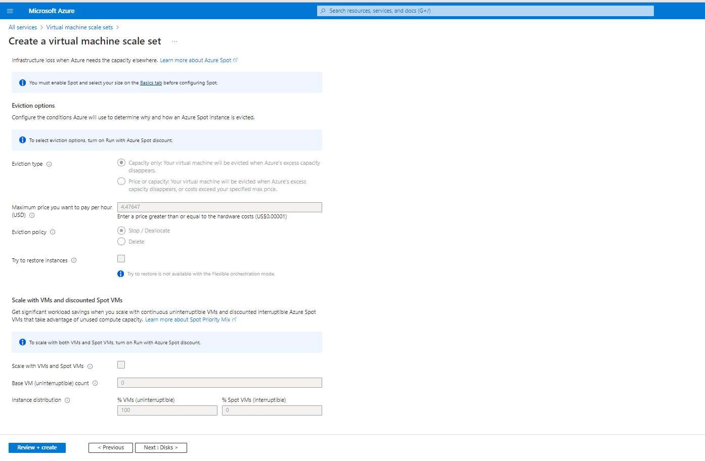

Default changes

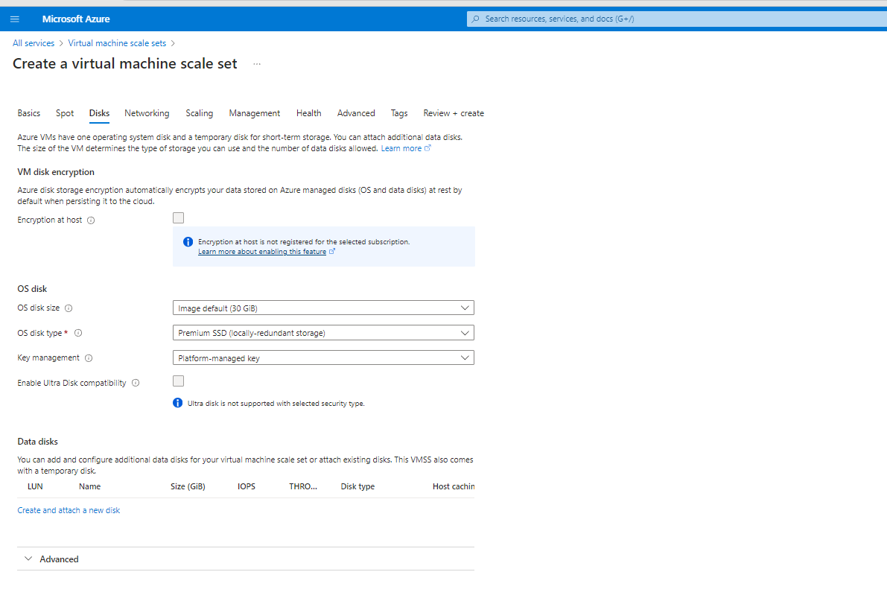

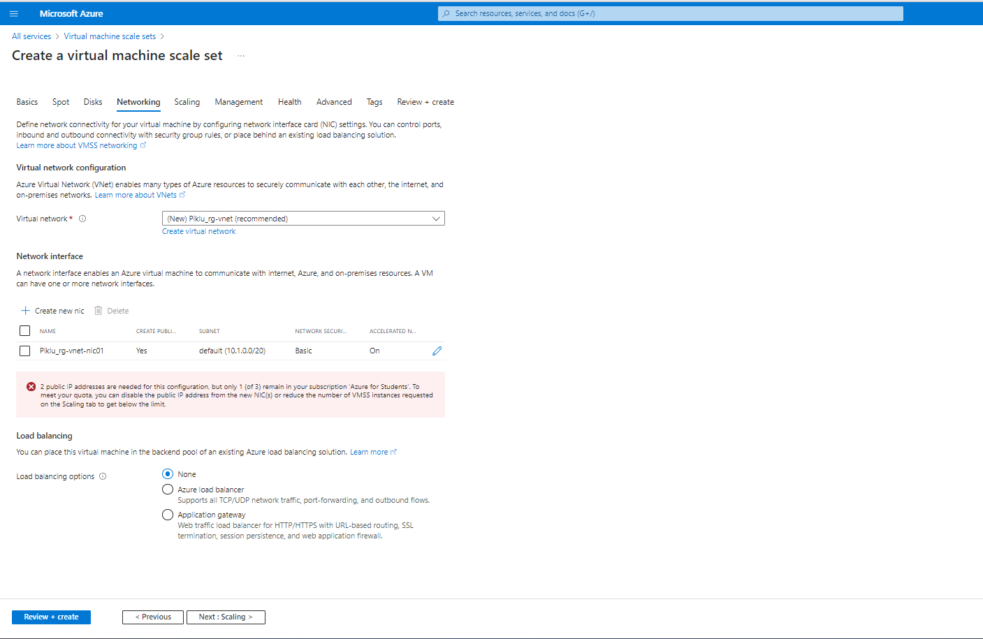

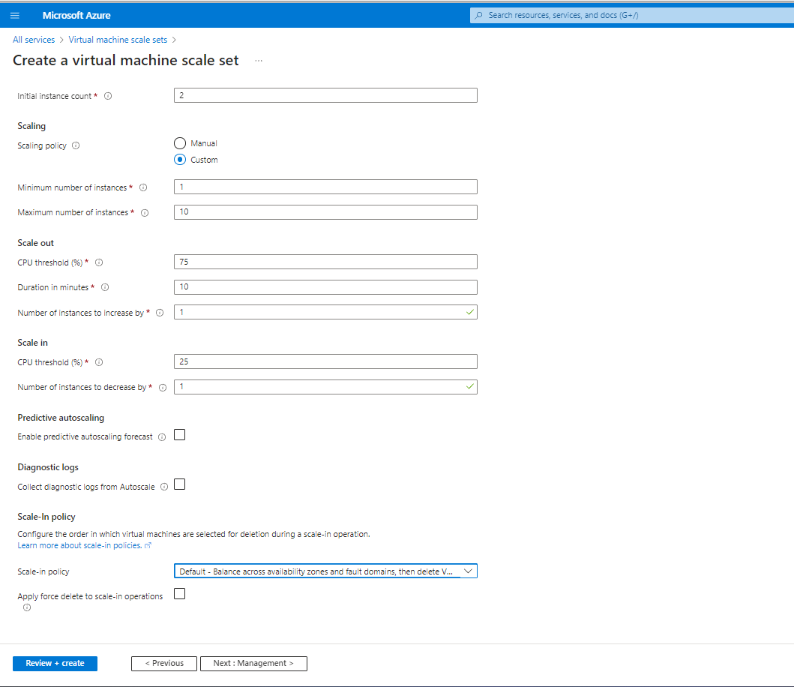

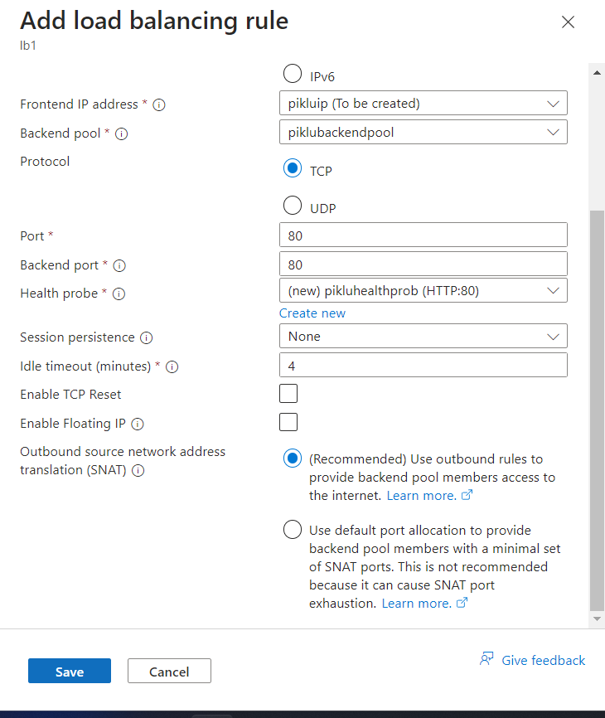

AWS Application Load Balancer

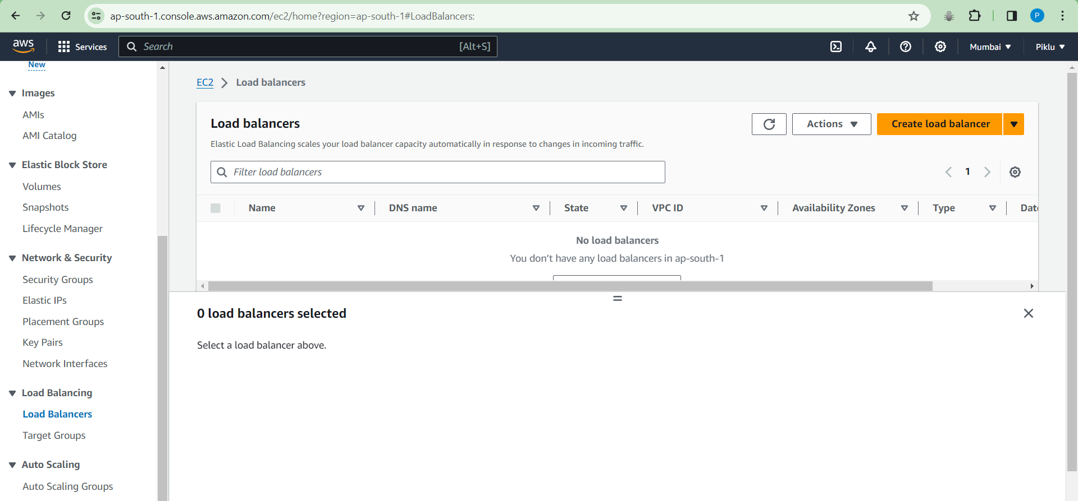

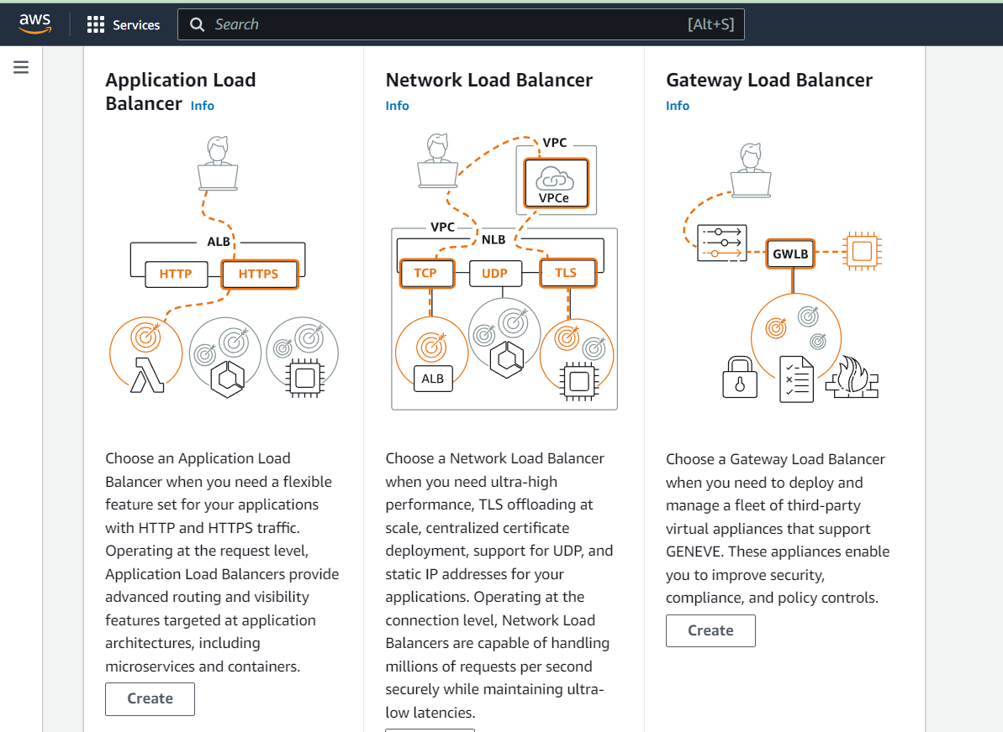

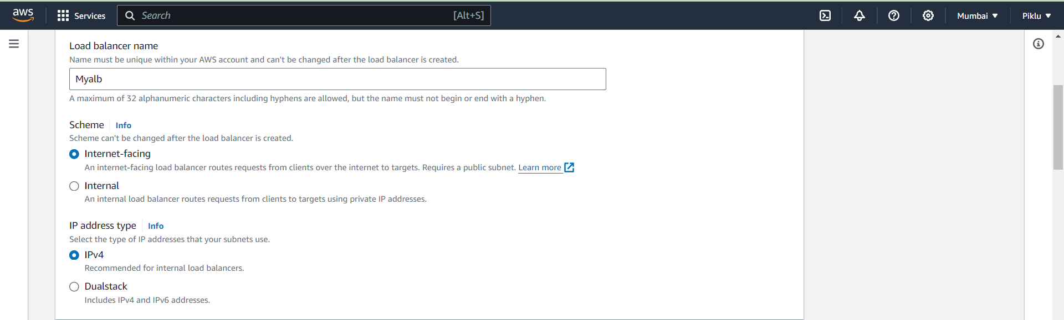

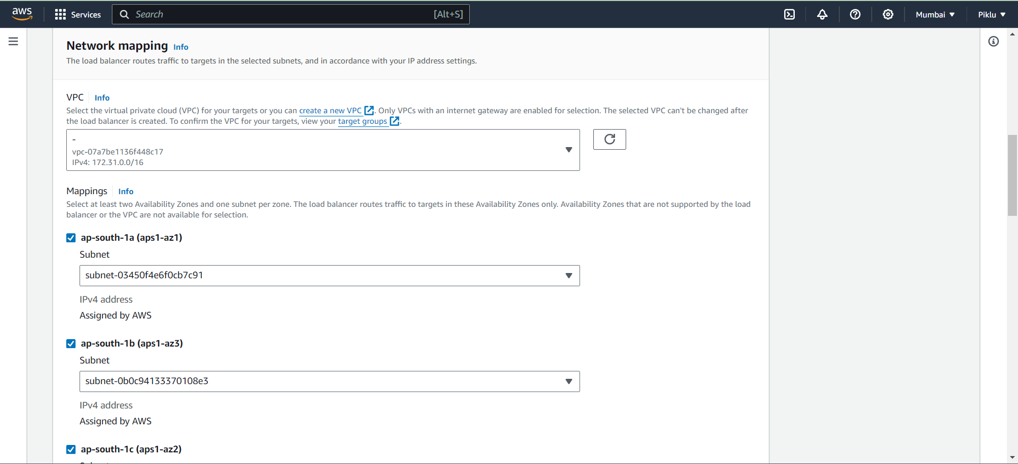

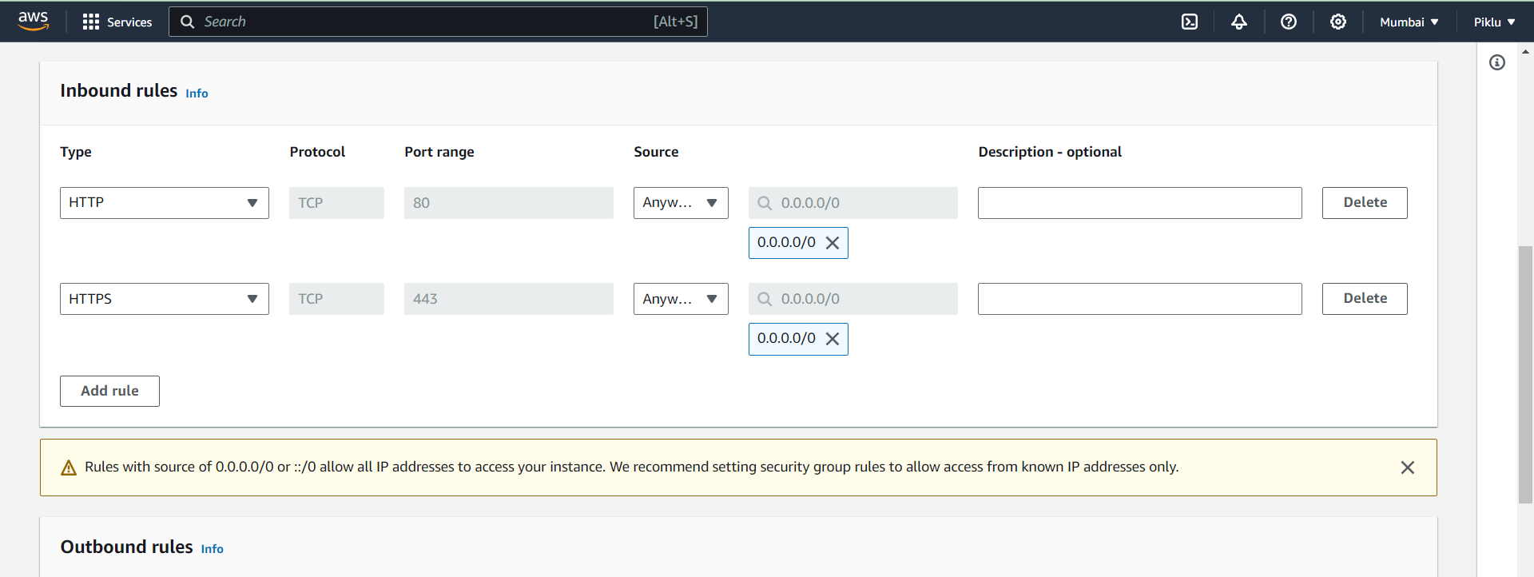

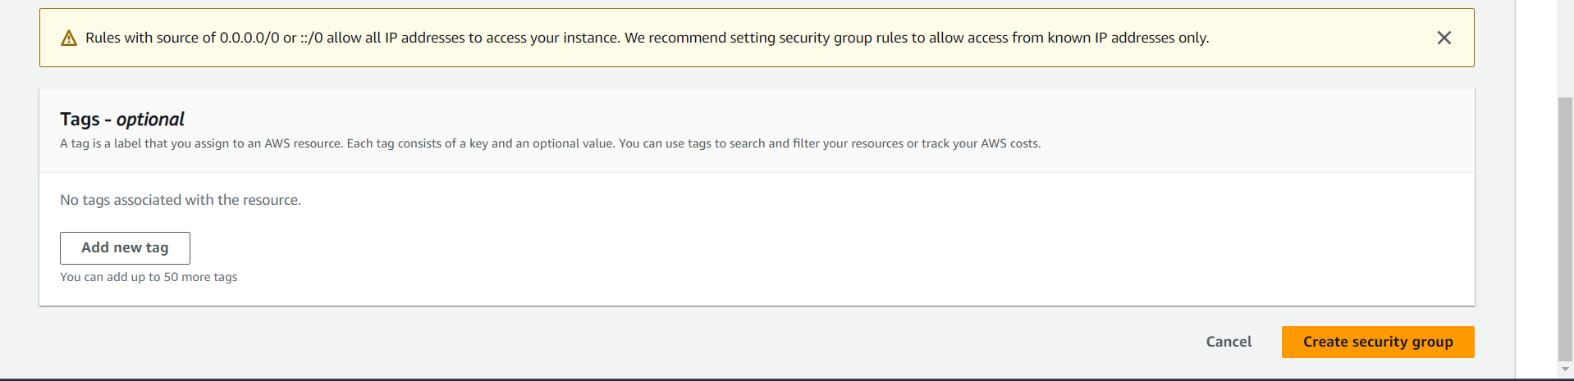

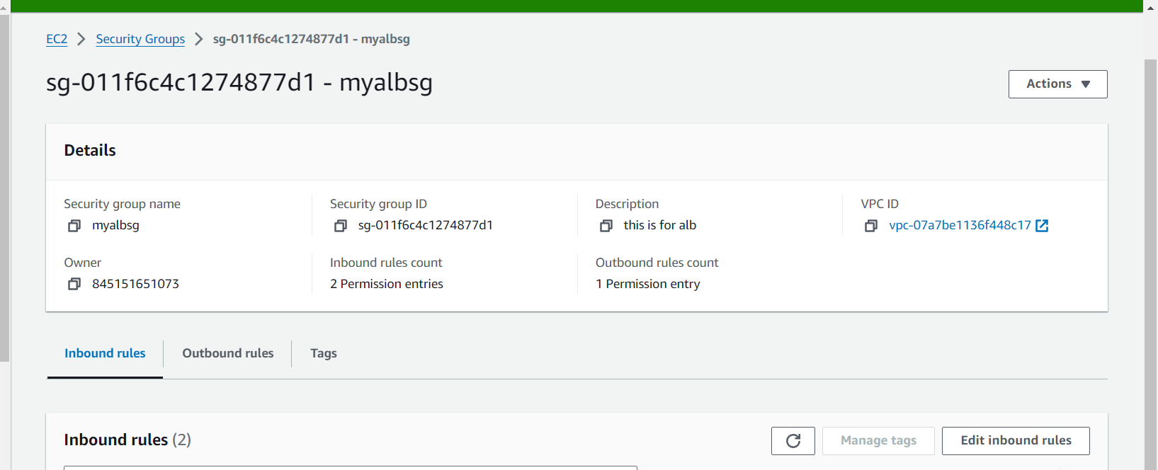

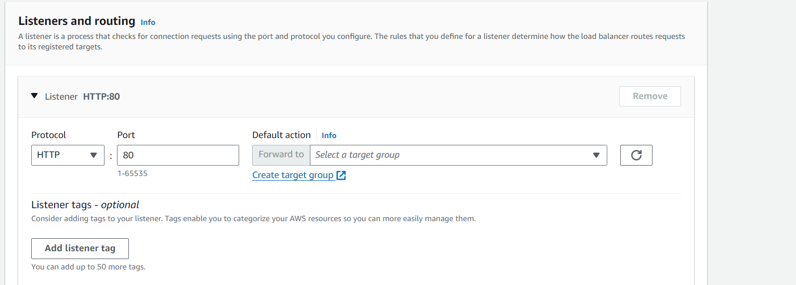

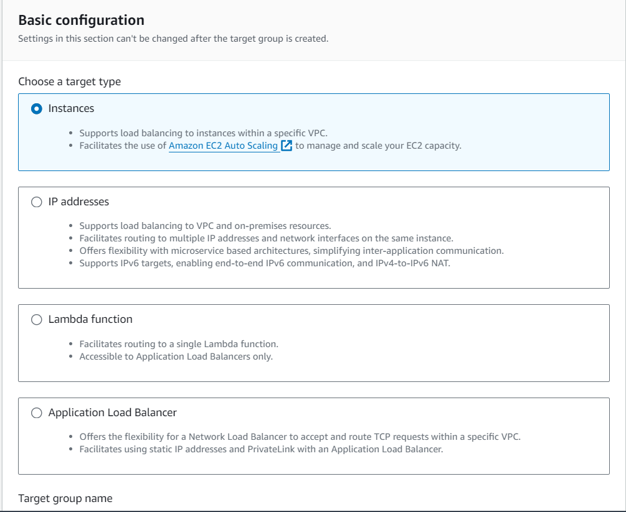

Remaining settings are default

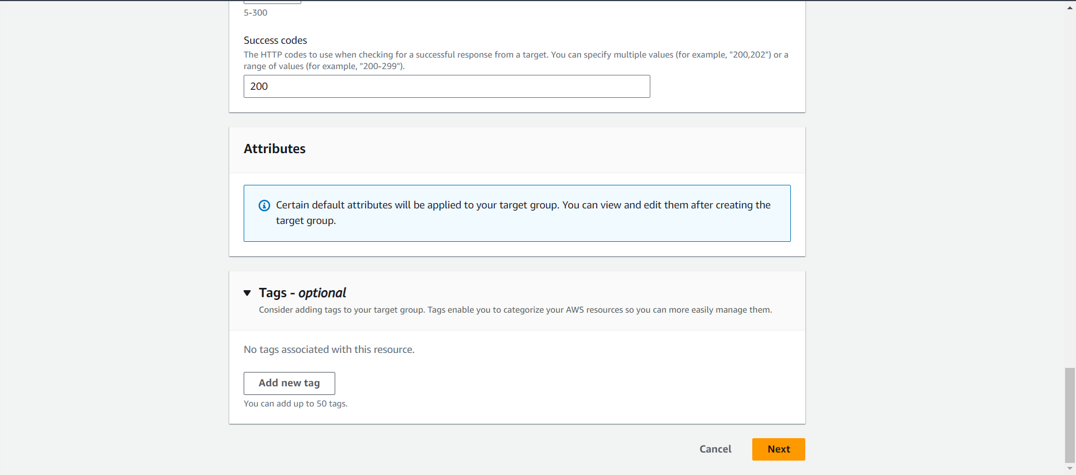

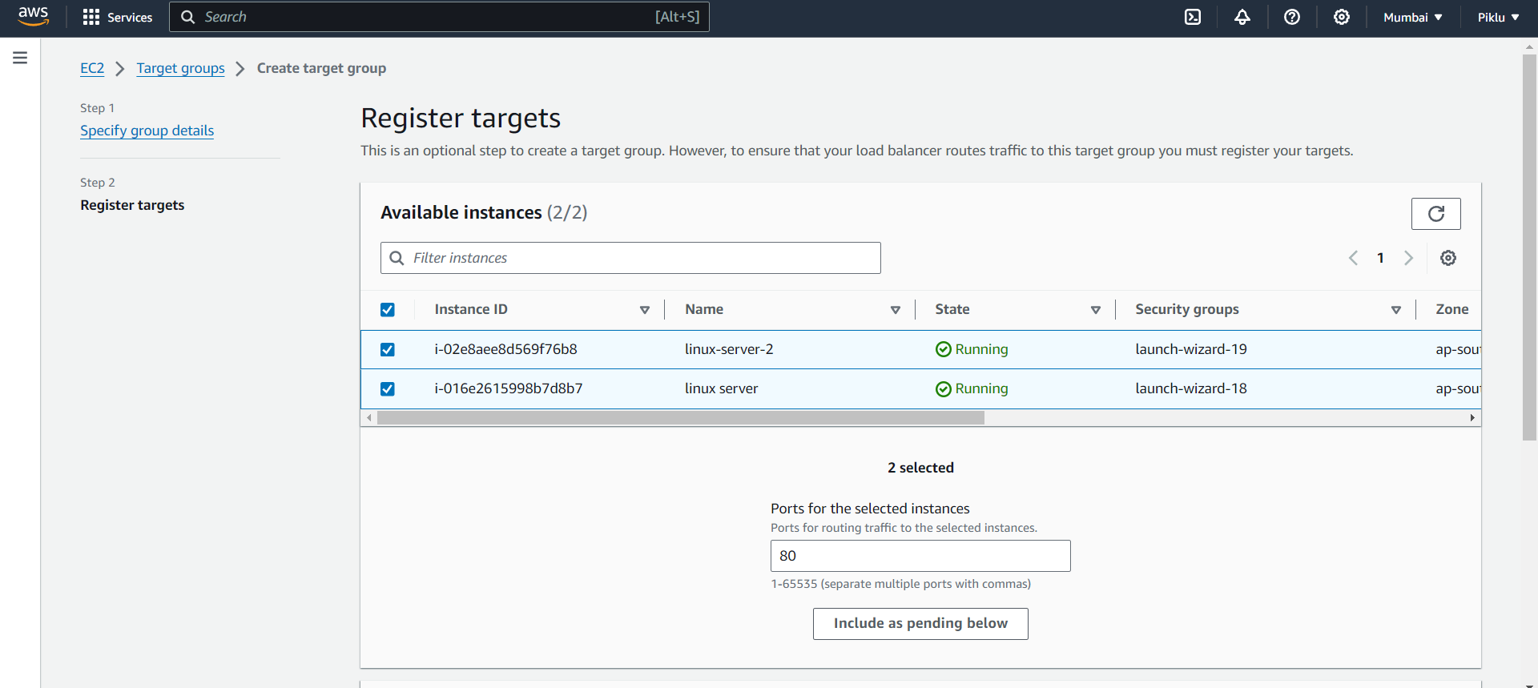

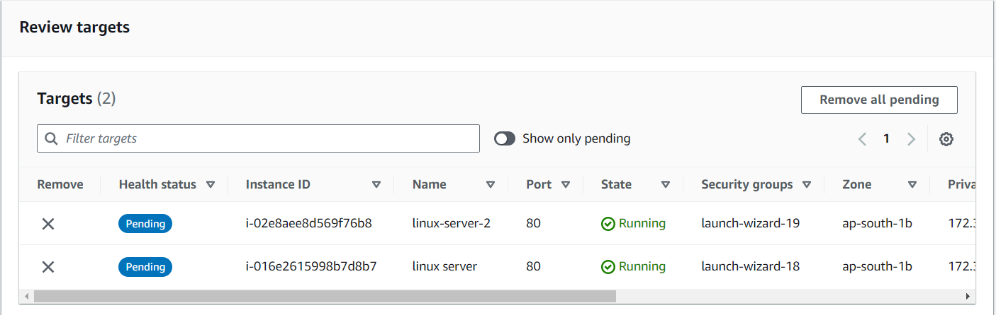

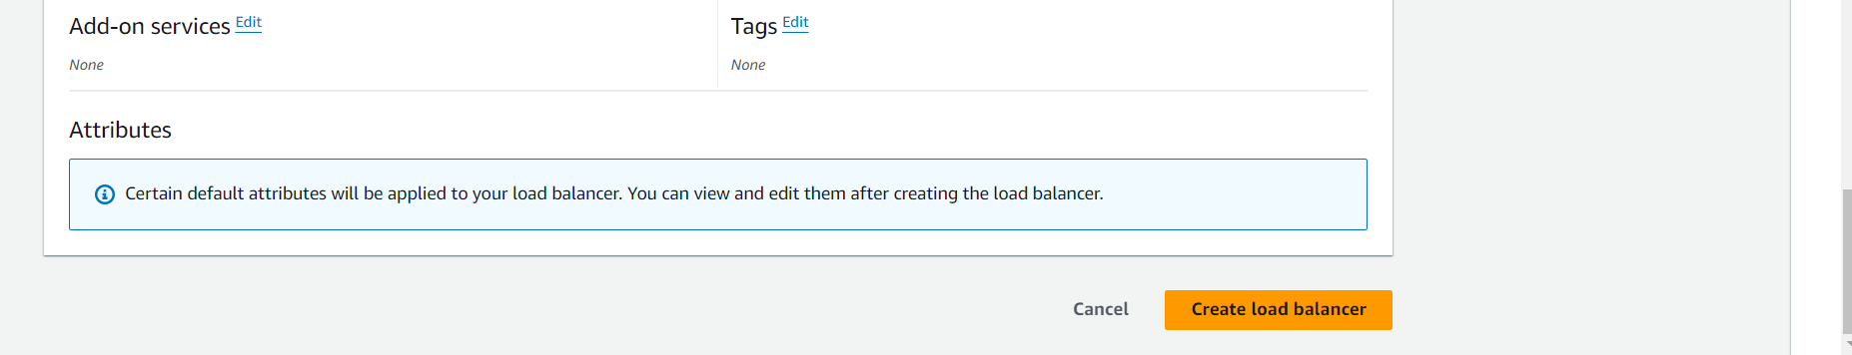

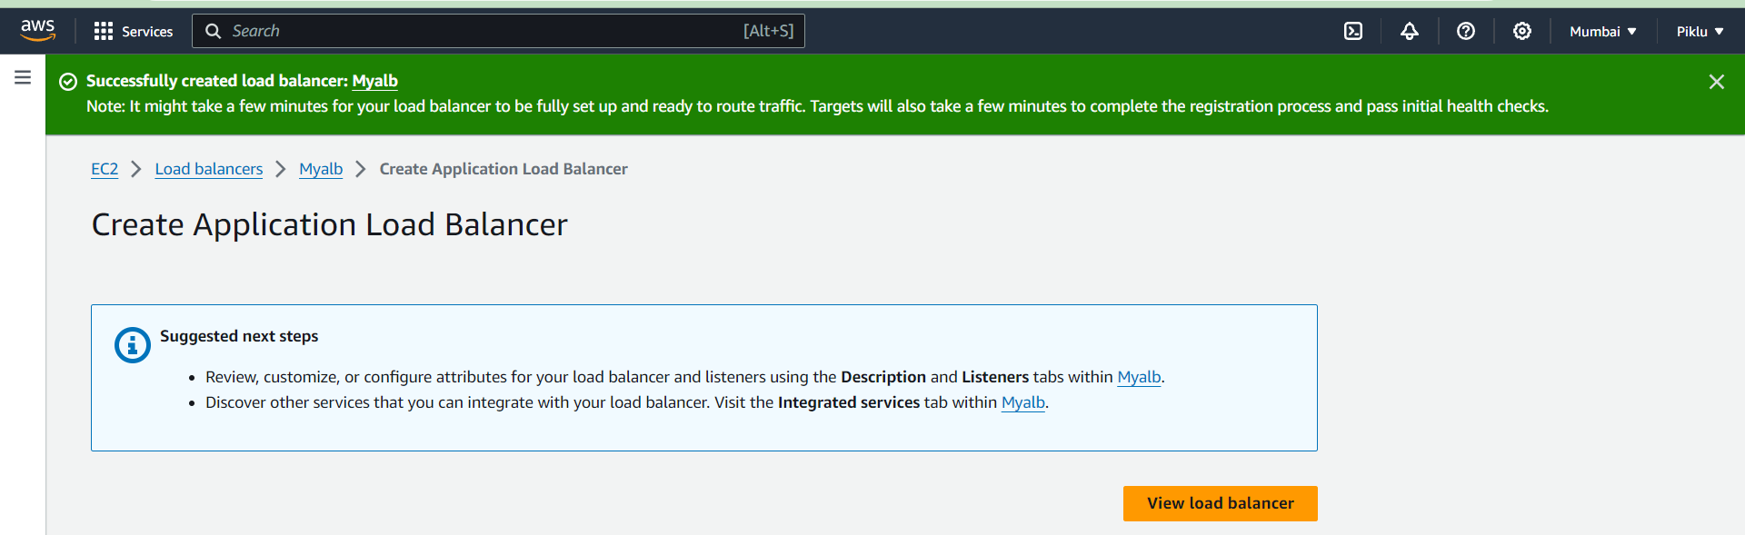

Graph

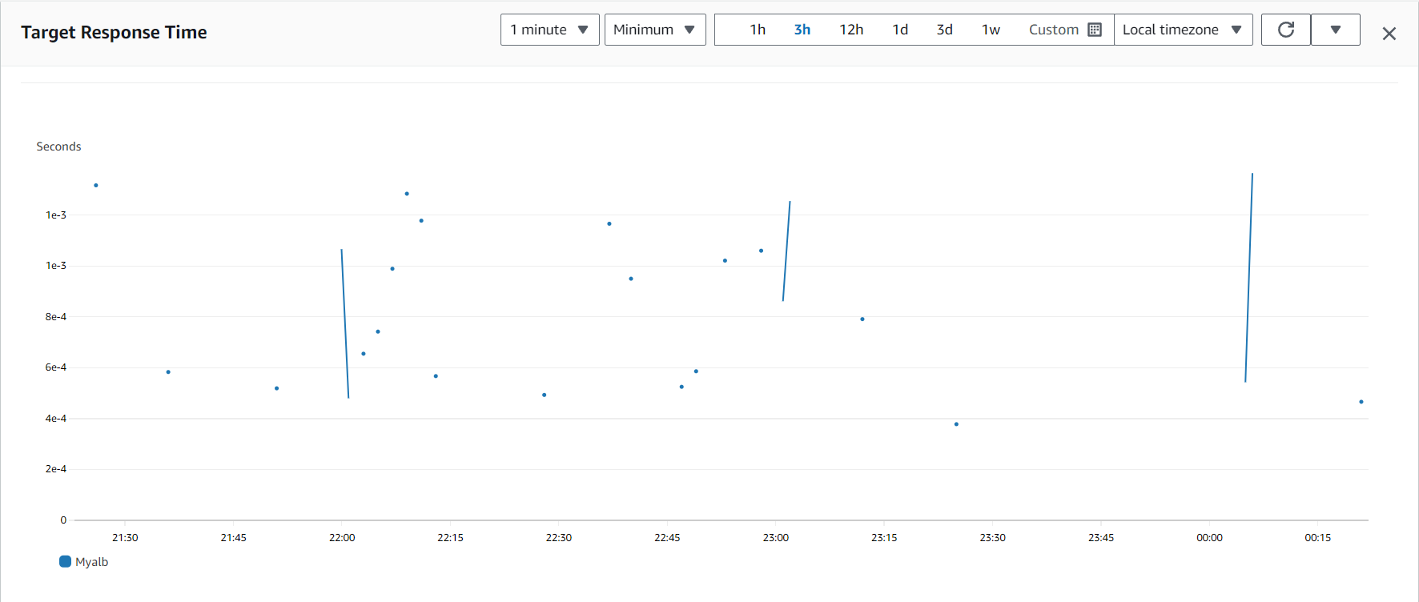

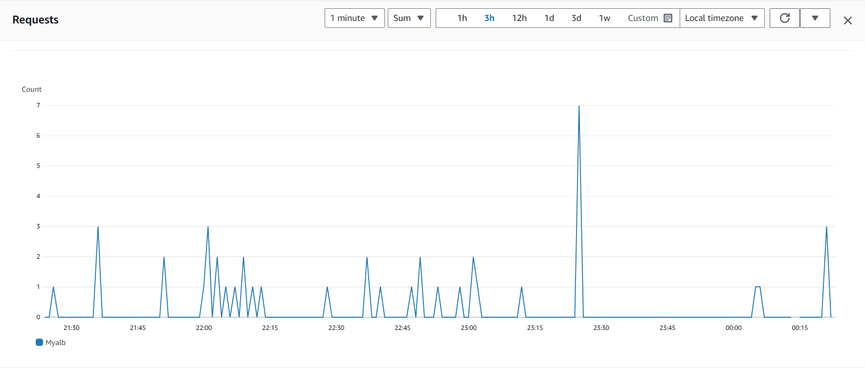

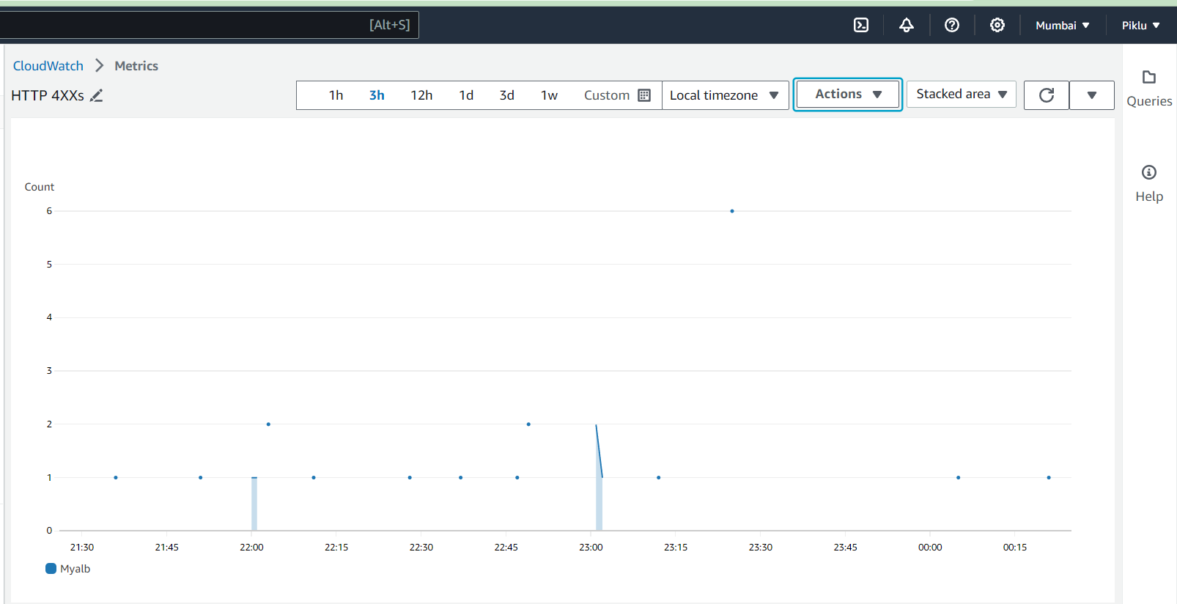

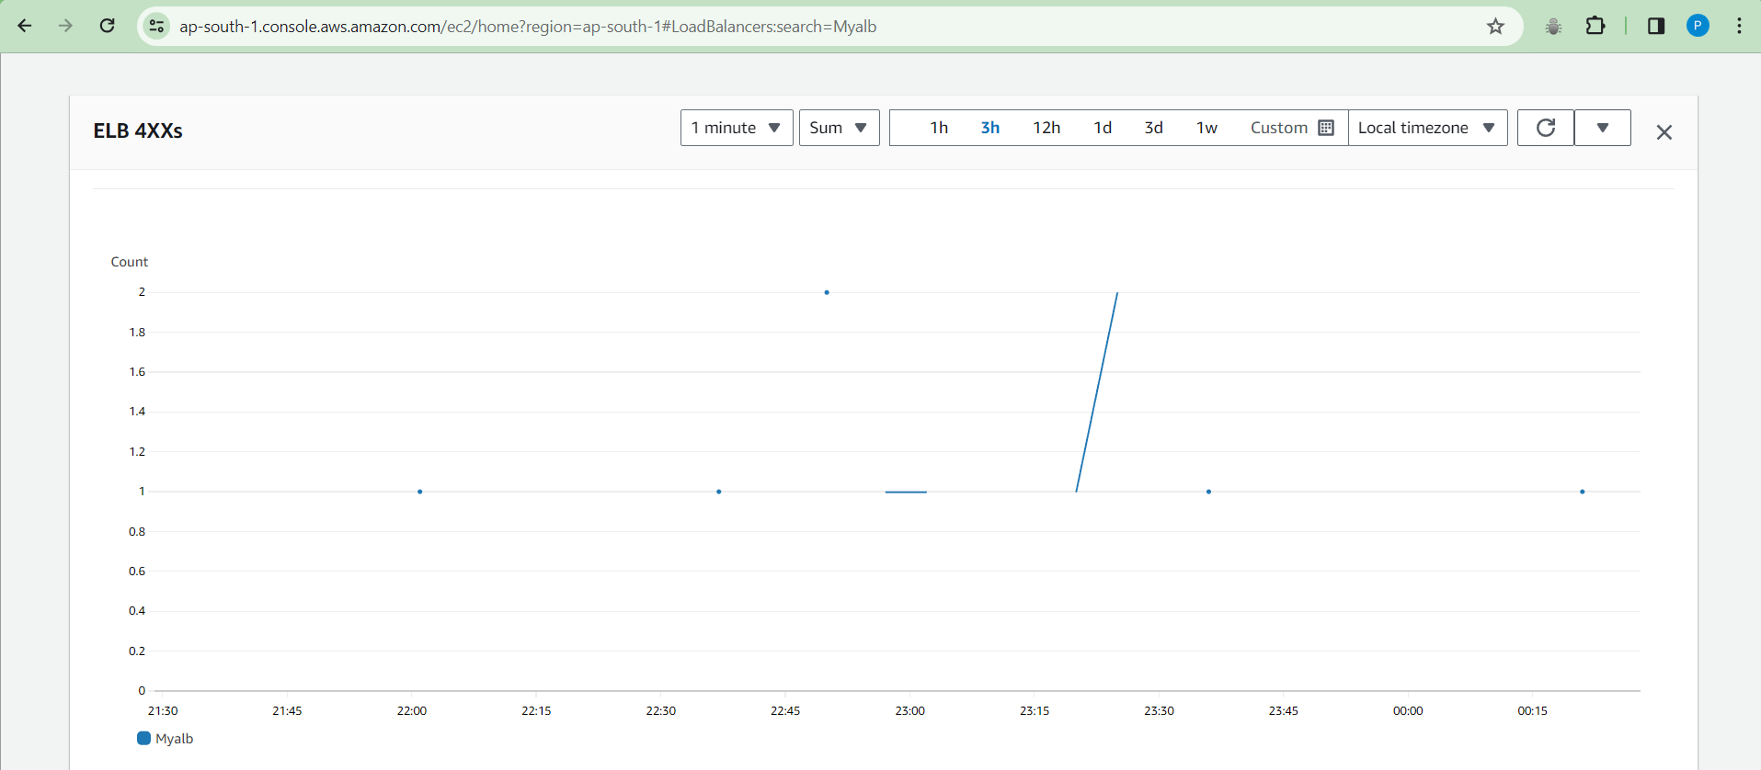

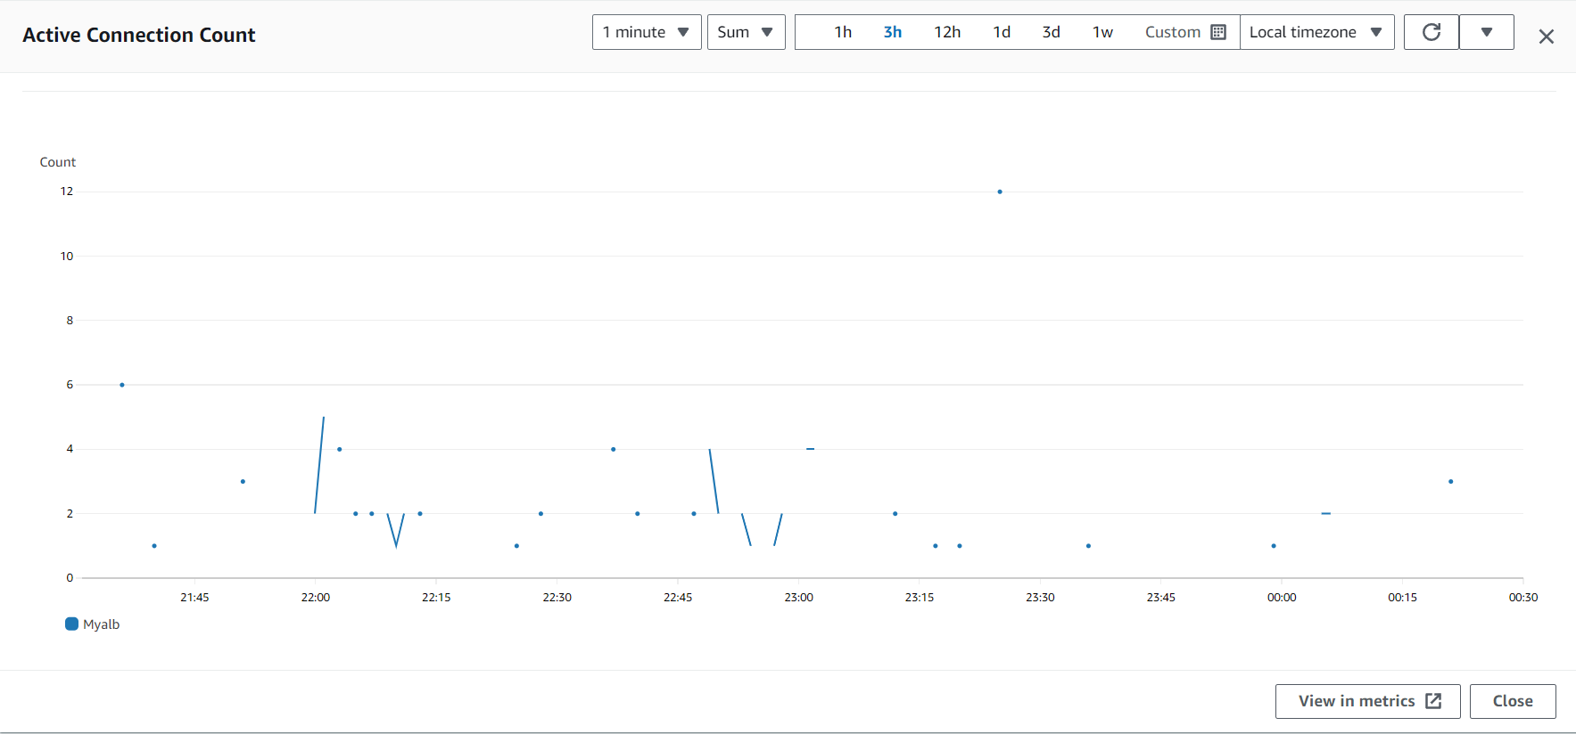

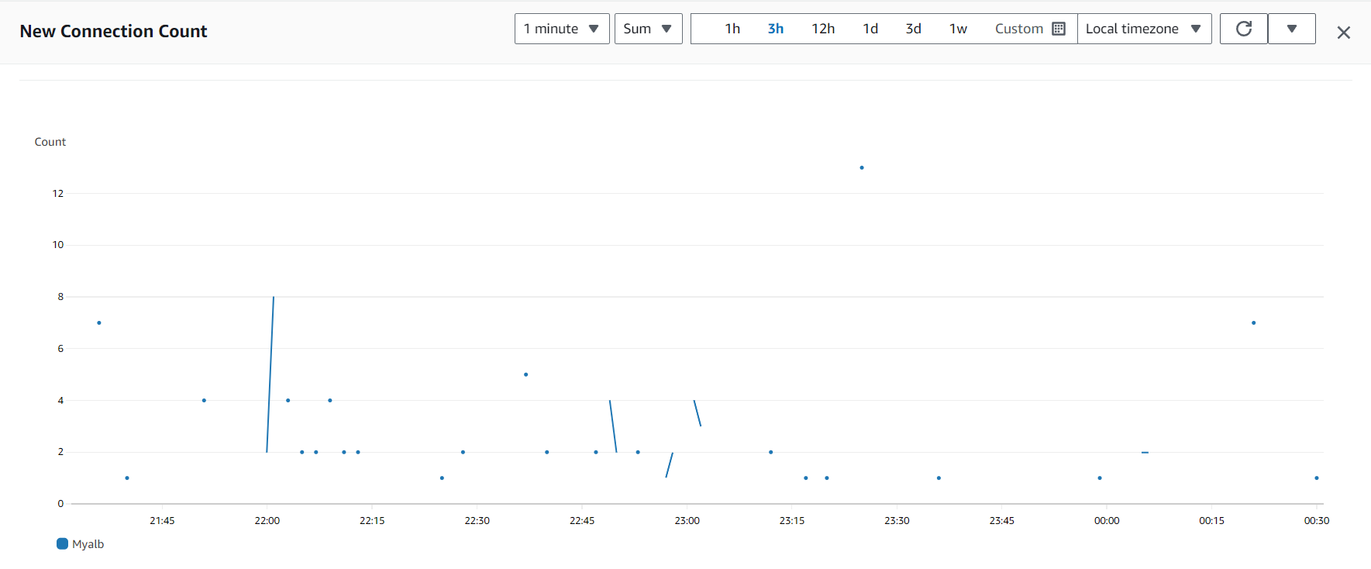

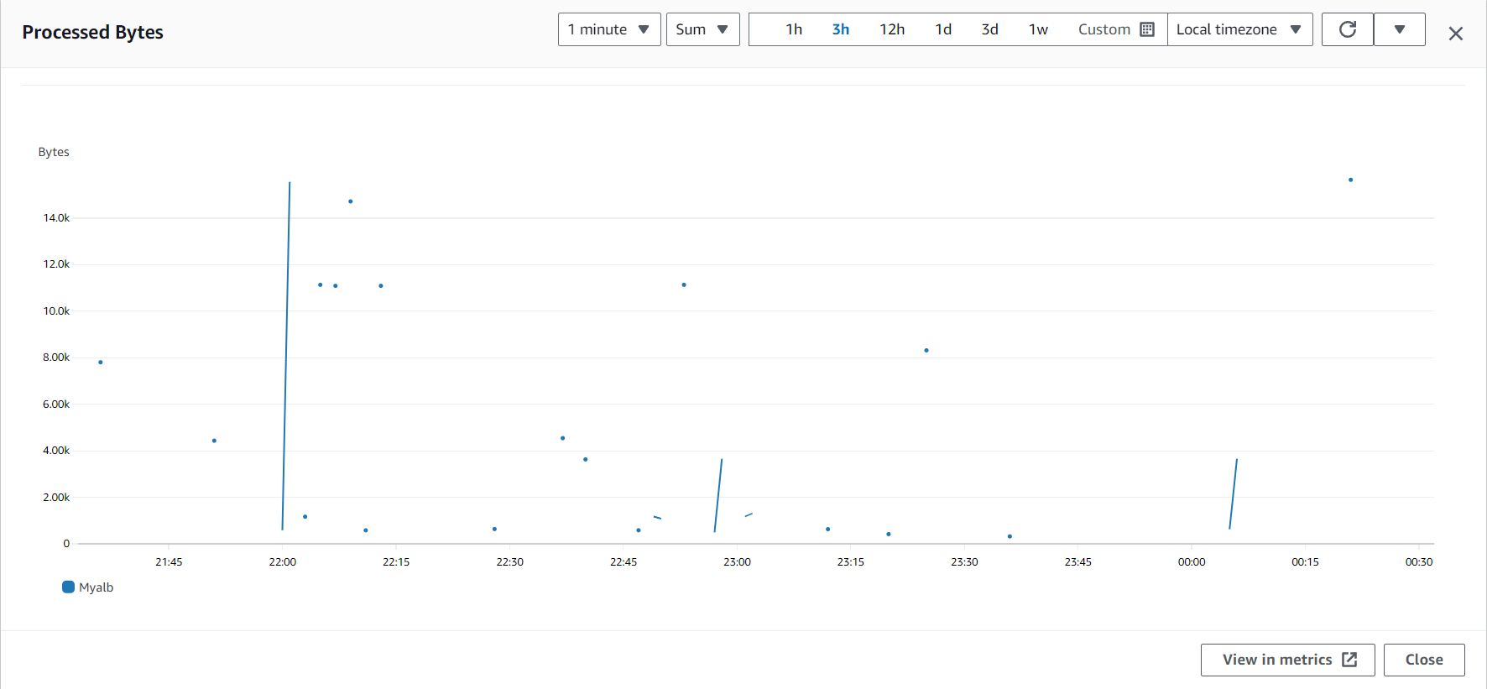

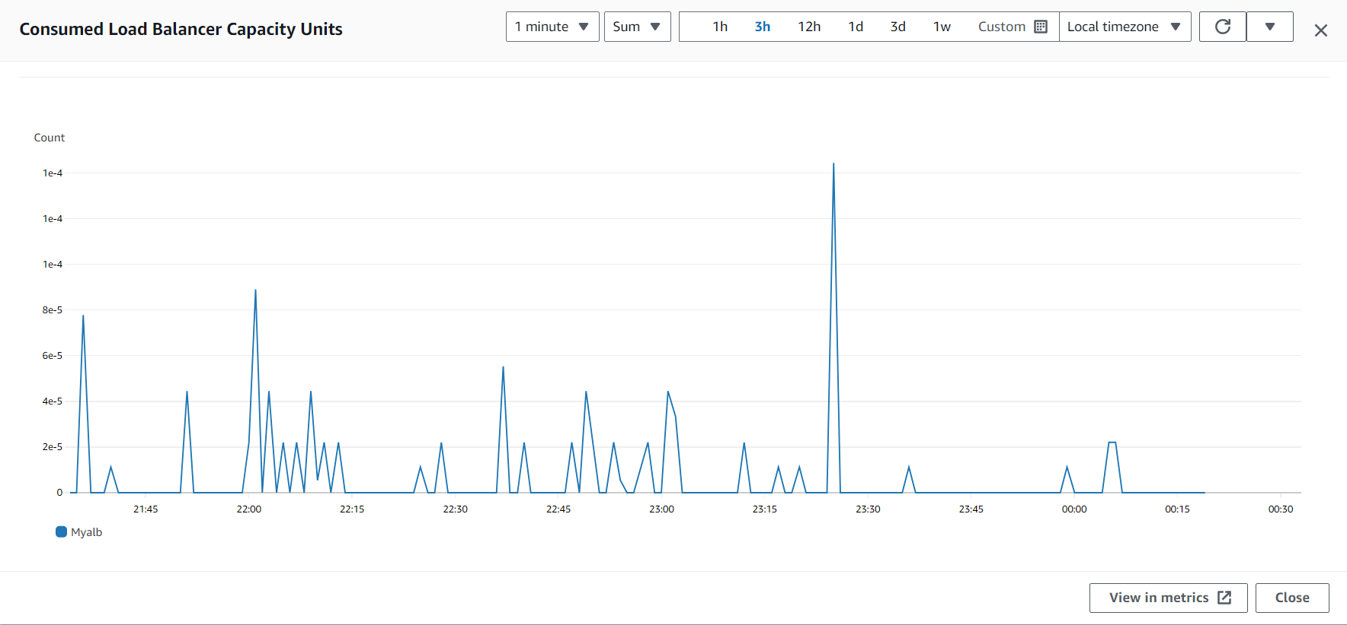

Autoscaling Group for application availability:

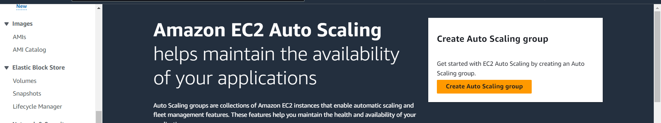

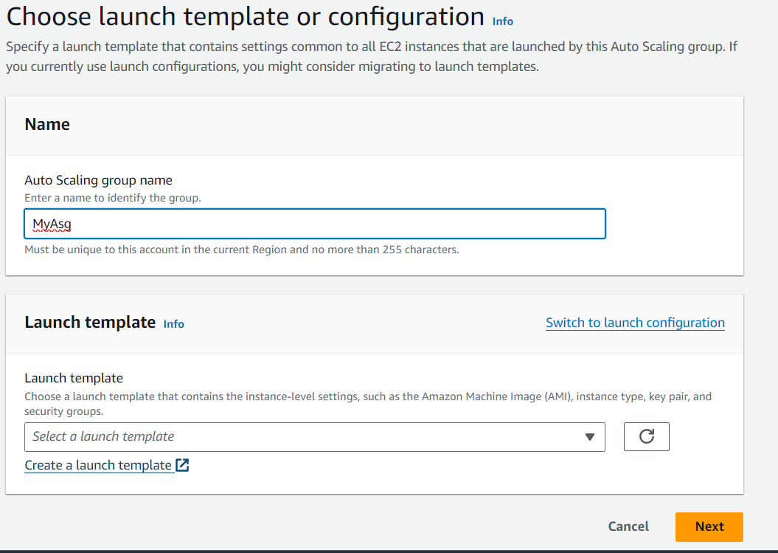

Now create a launch Template

Create your instance image

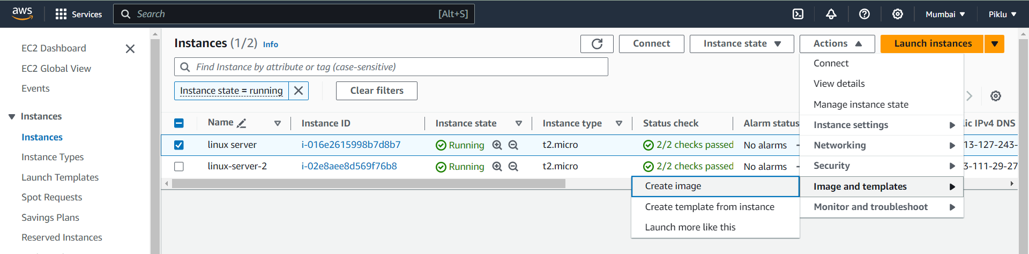

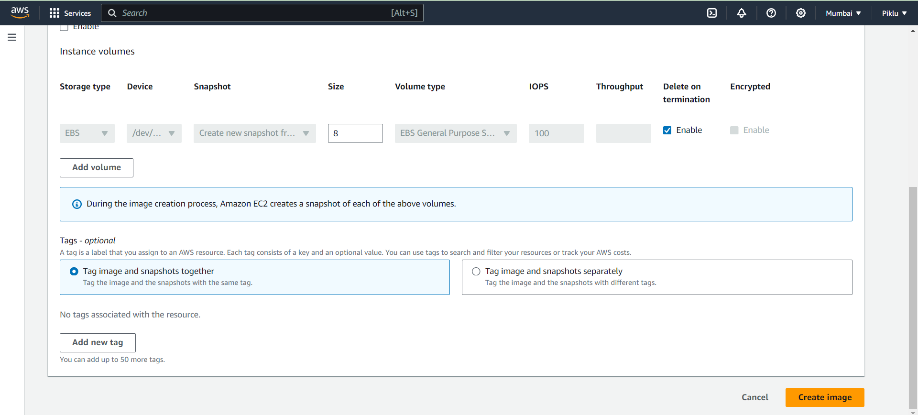

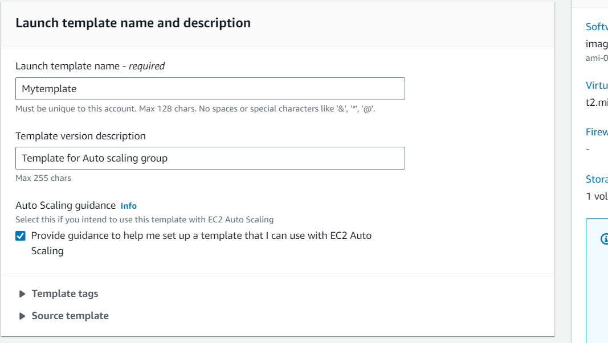

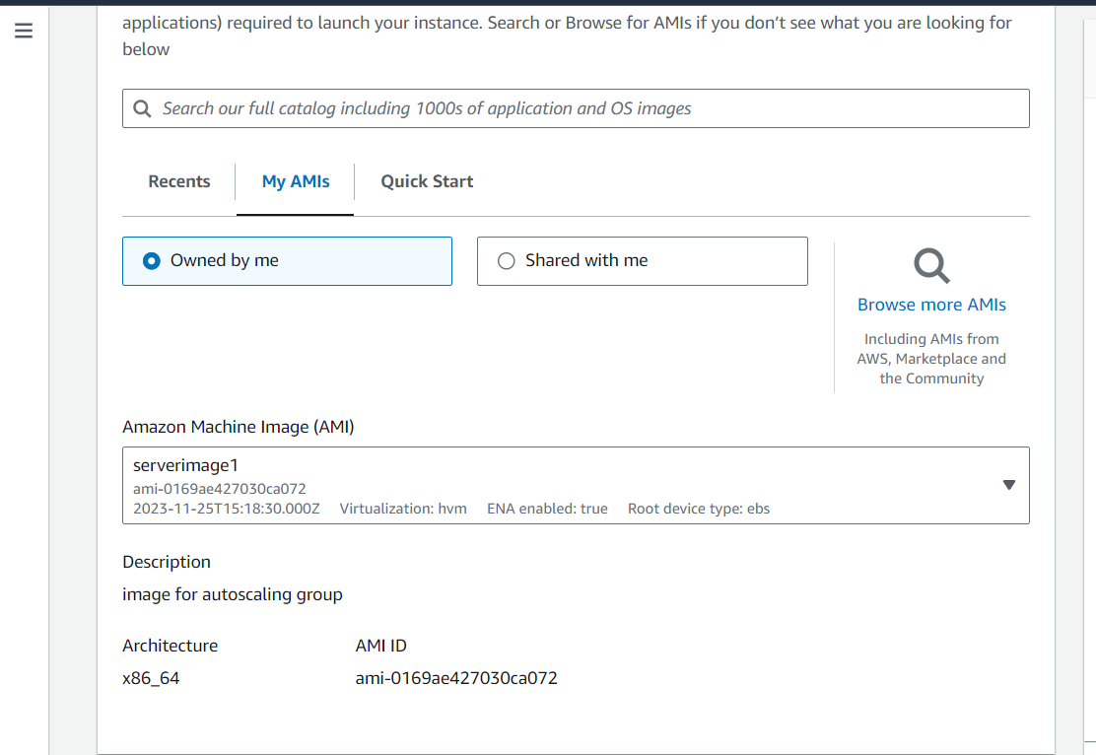

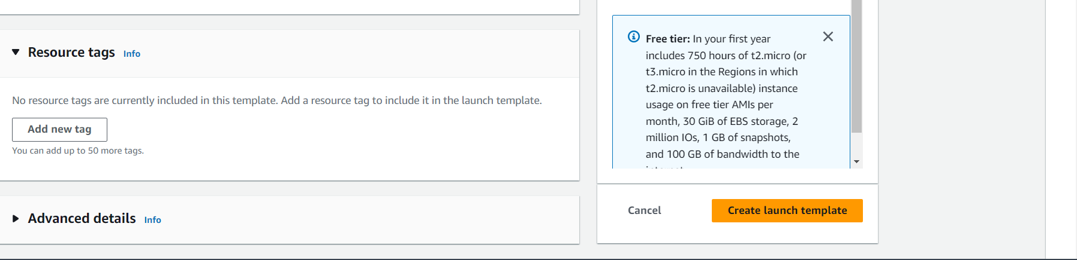

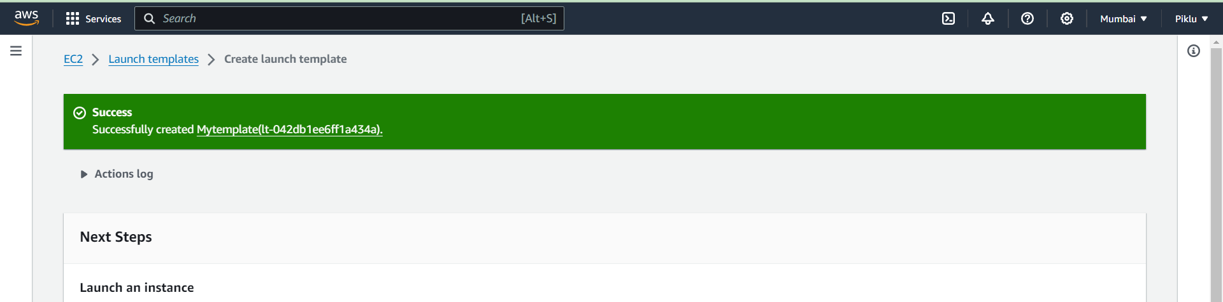

Goto autoscaling group refresh template section and select your own template, and also click next

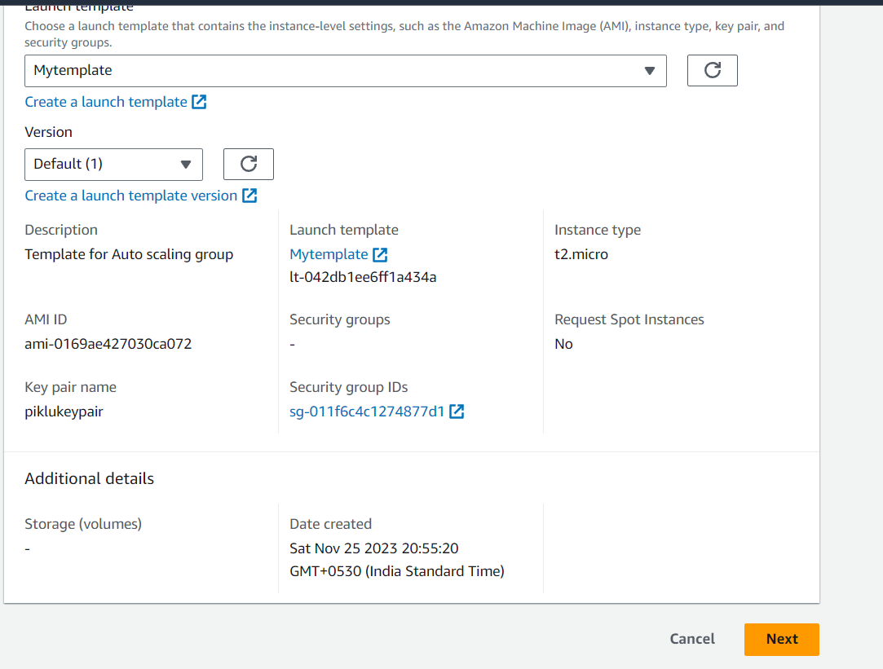

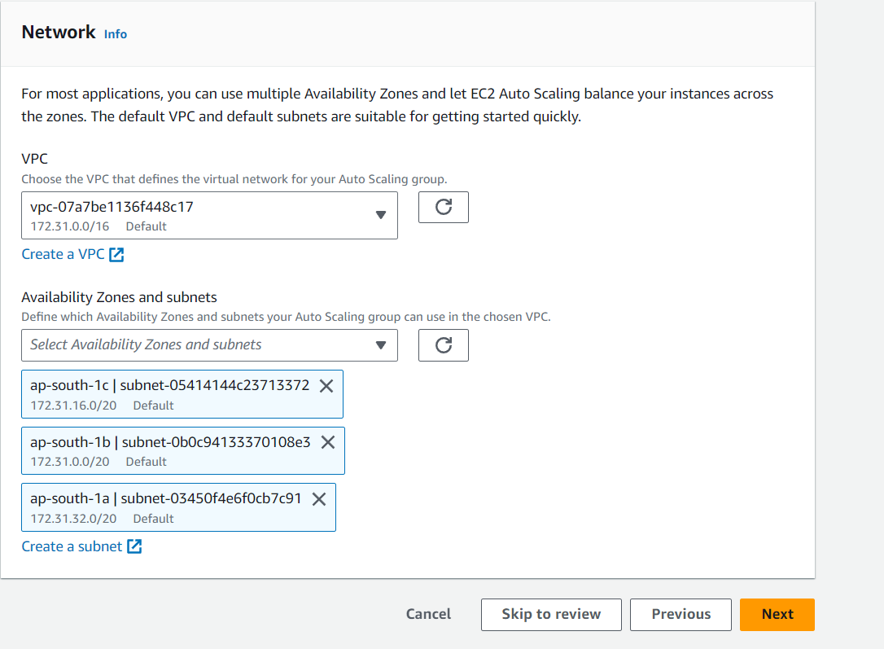

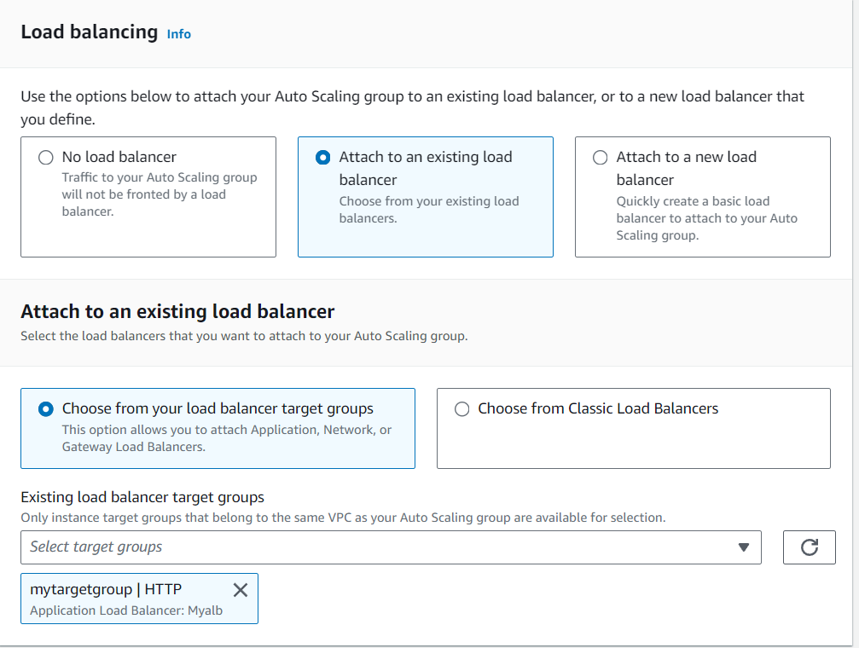

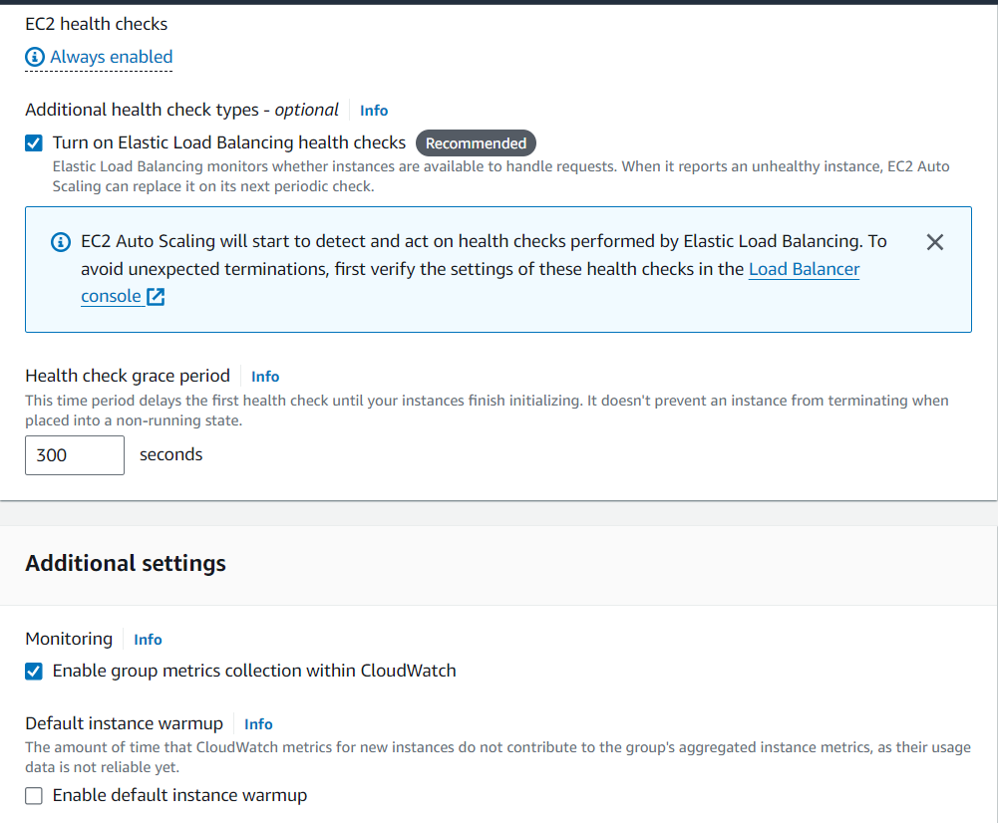

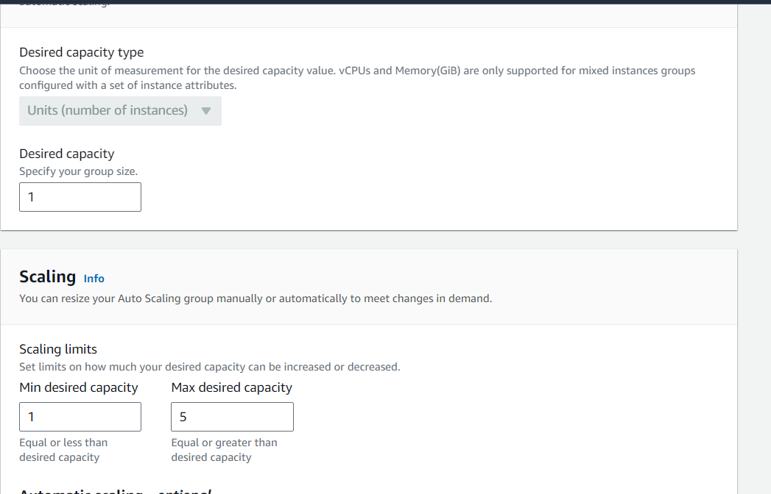

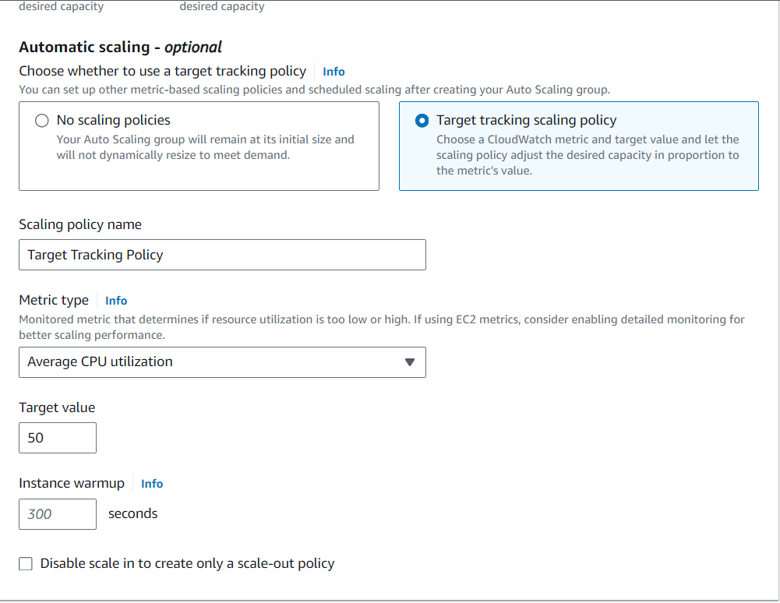

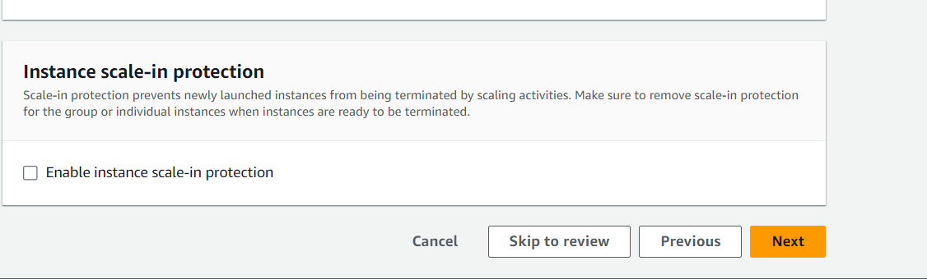

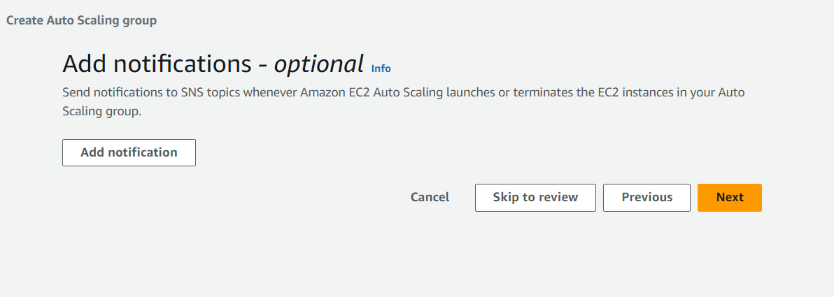

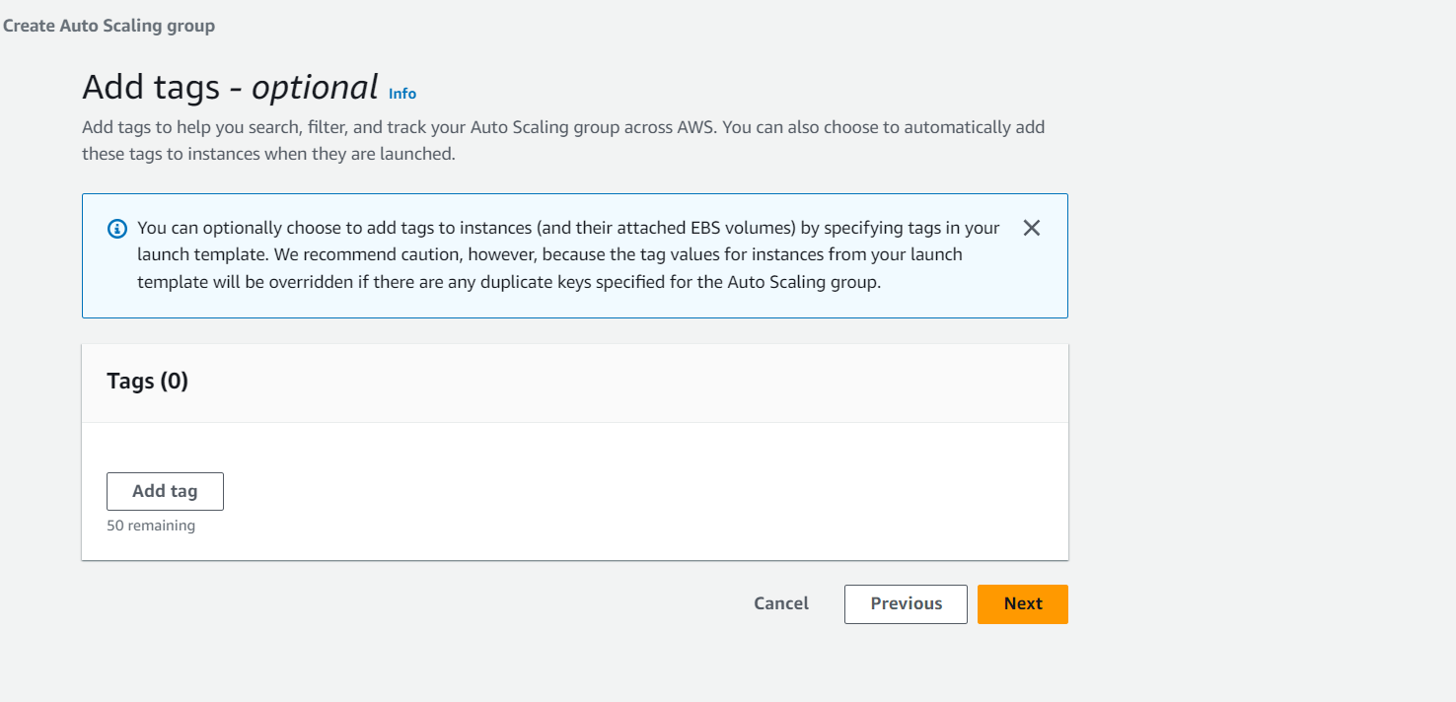

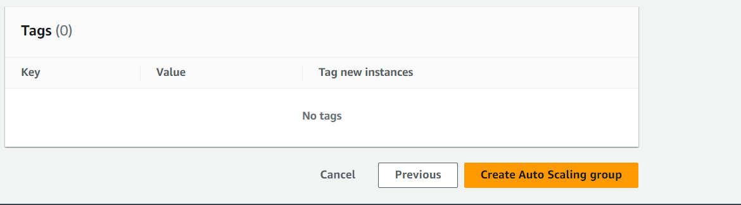

When I delete one instance then automatically run another instance because desire state is 2

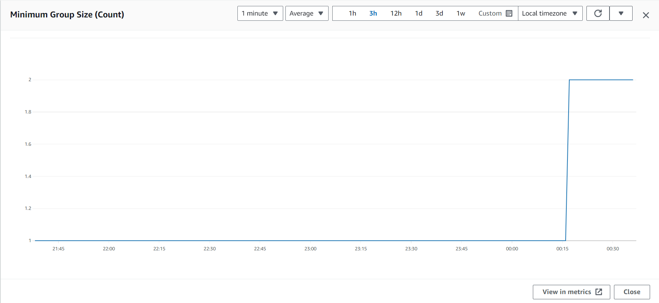

I am set maximum 5 instance

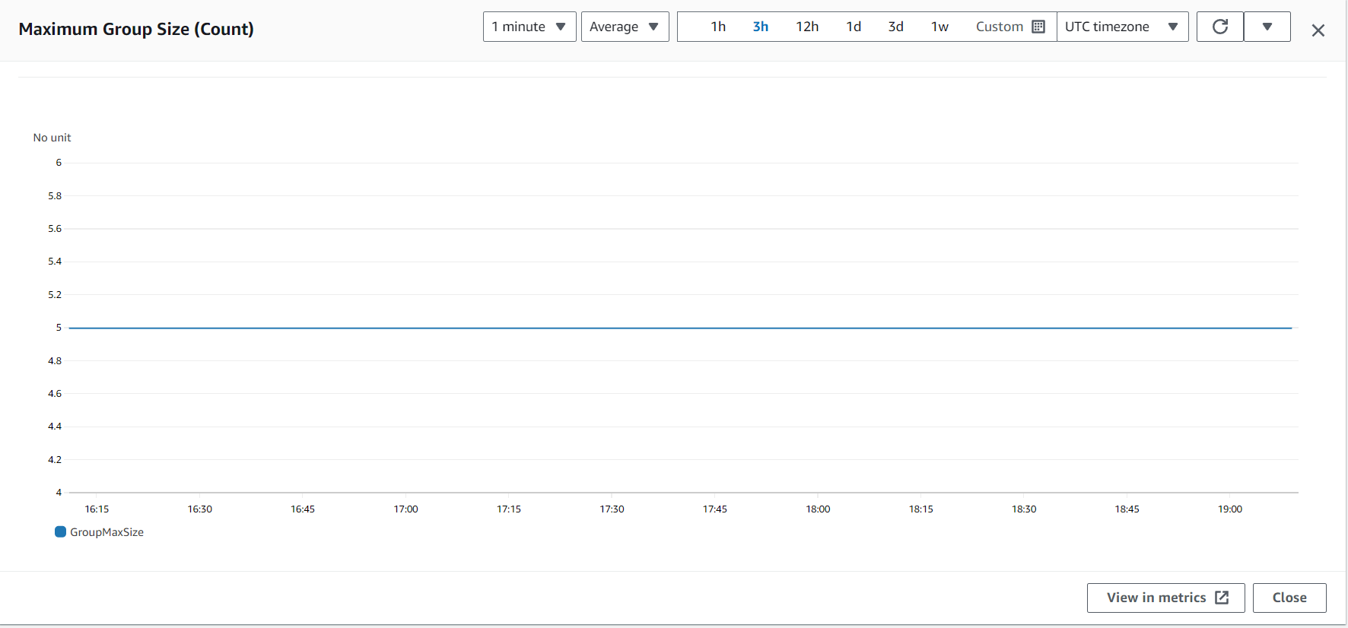

Service instance is 2

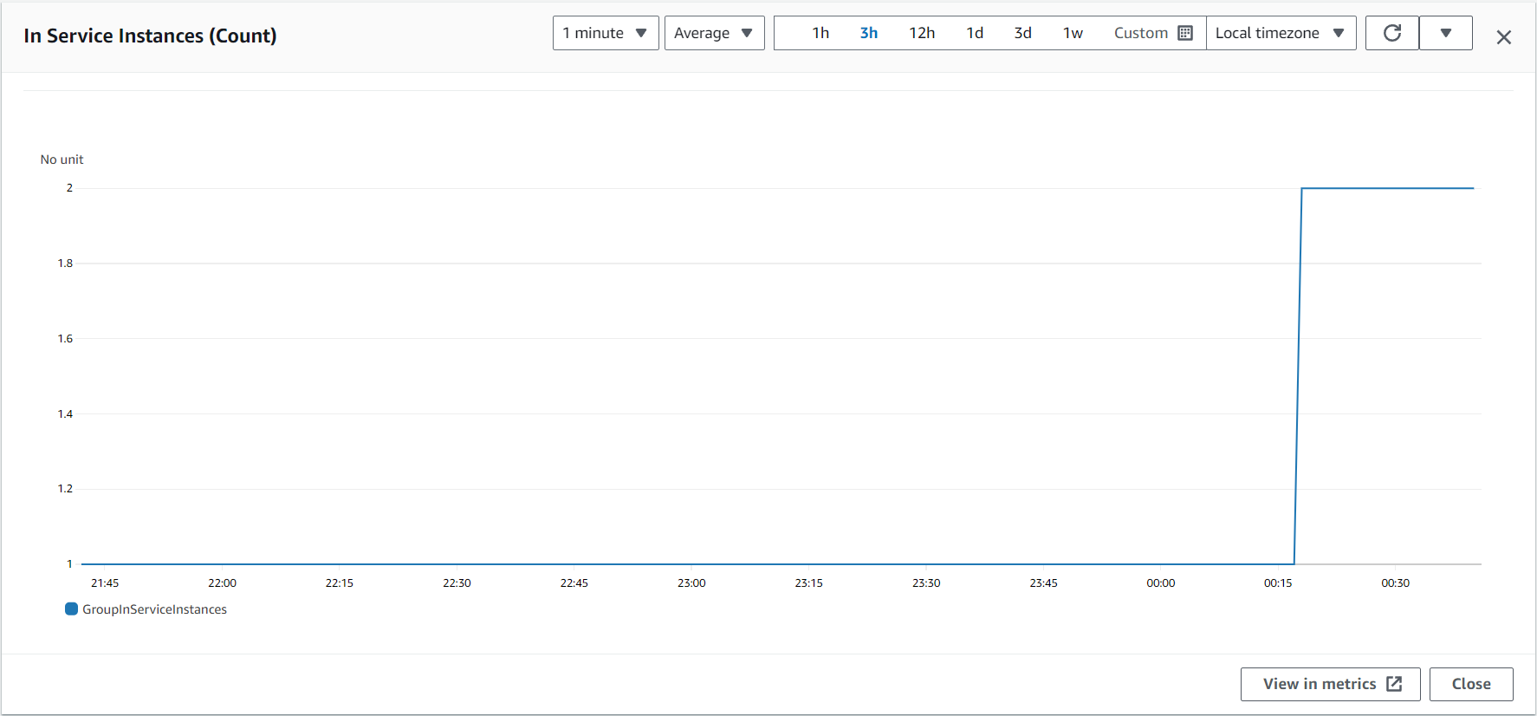

When I am delete one instance then one instance automatically created then that time that instance pending state

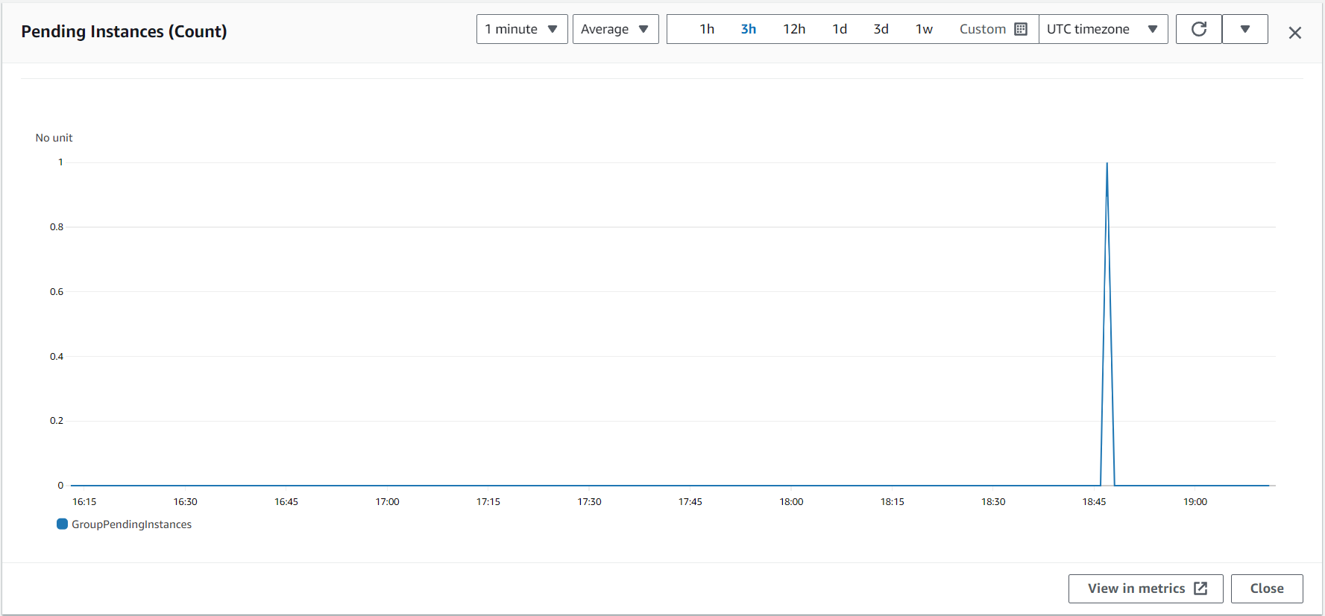

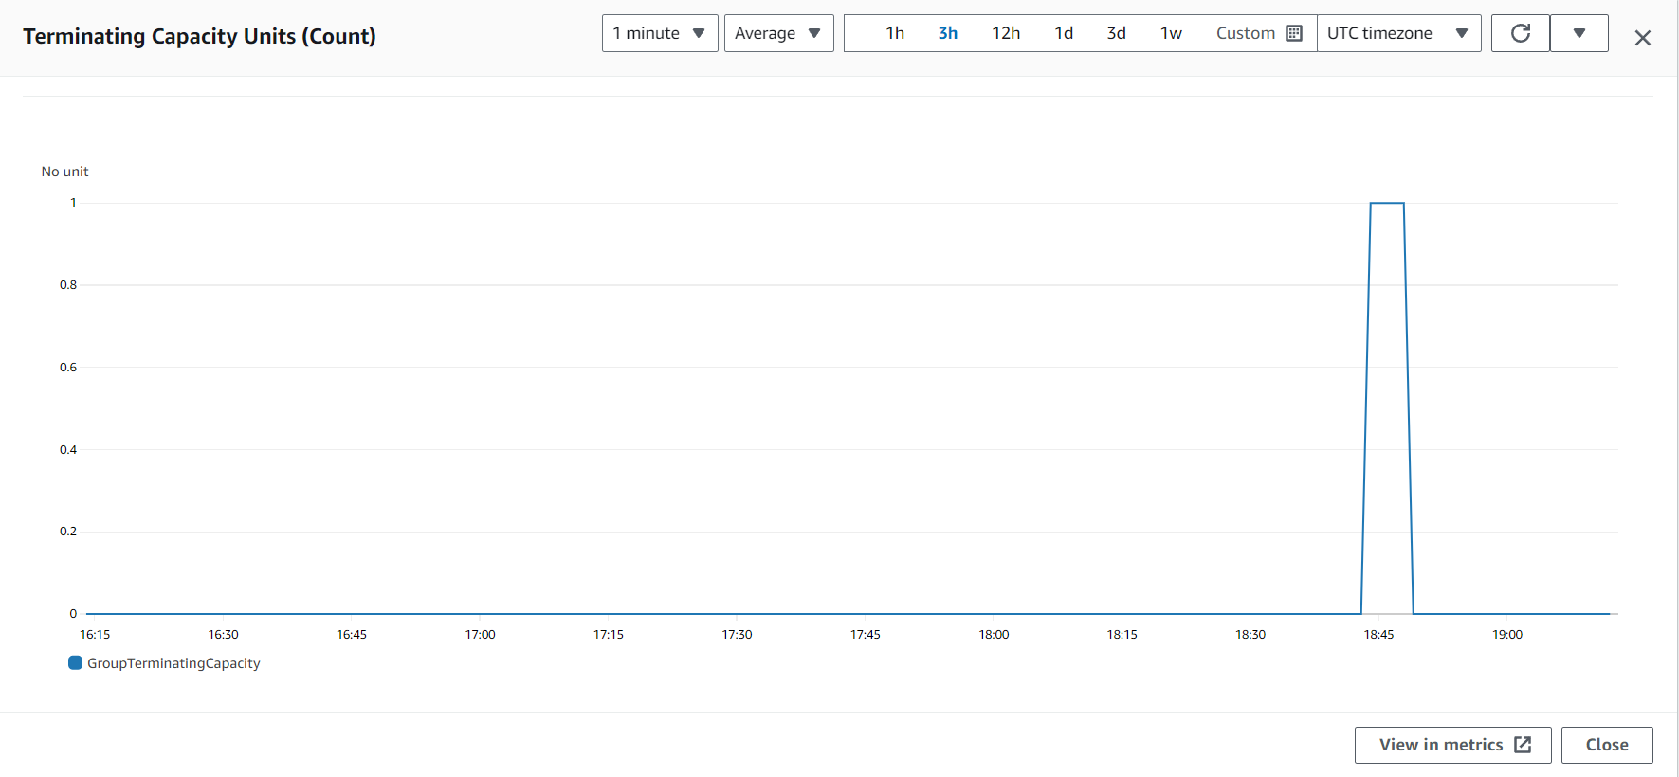

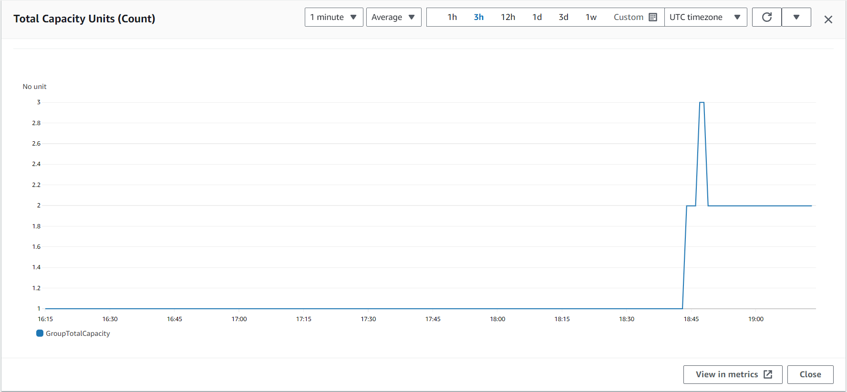

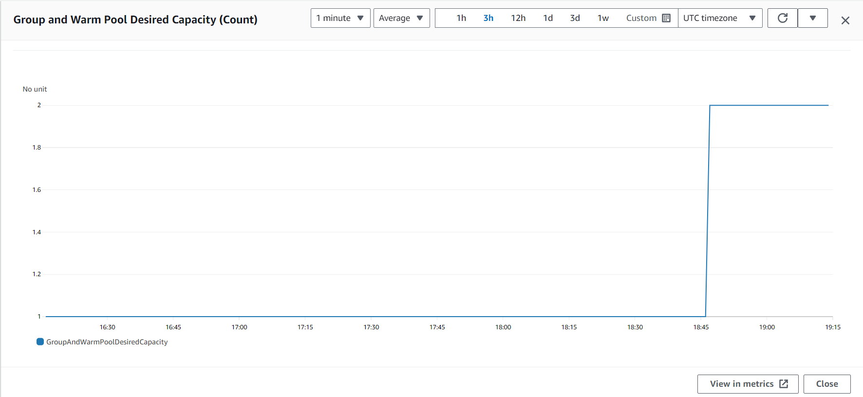

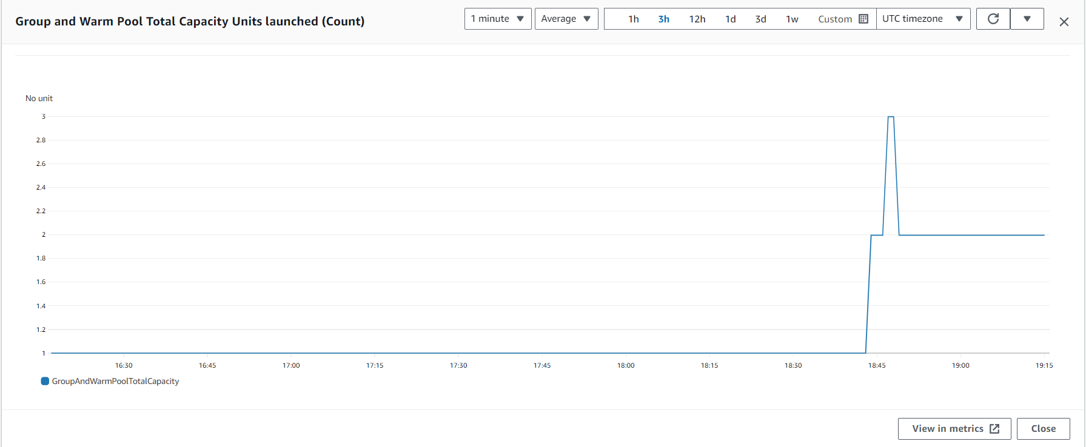

**Conclusion**

In conclusion, the project to host the portfolio website on a cloud platform has successfully navigated through comprehensive planning, theoretical exploration, and practical implementation. The utilization of a theoretical framework grounded in the Cognitive Process Theory, coupled with insights from a robust literature review, has guided decision-making at each stage of the project. The incorporation of cloud hosting best practices, performance optimization strategies, and emerging technologies ensures that the deployed solution aligns with industry standards while remaining adaptable to evolving trends.

The collaborative effort within the project team, informed by stakeholder feedback and primary data sources, has contributed to a holistic approach. Emphasis on load balancing, auto-scaling, and resource optimization fosters a scalable and responsive system. Continuous monitoring and adherence to security best practices further enhance the reliability and integrity of the hosted portfolio website.

As the project concludes, ongoing optimization and monitoring practices will be crucial to maintaining peak performance and addressing evolving requirements. Documentation and knowledge transfer sessions will facilitate seamless maintenance and troubleshooting, ensuring the sustained success of the cloud-hosted portfolio.

**Which Is better (Windows/Ubuntu)**

Regarding the choice between hosting a Windows instance and an Ubuntu instance, the decision should be based on specific project requirements, compatibility with the application stack, and the team's expertise. Here are key considerations for each:

**Windows Instance:**

**Application Compatibility:** If the portfolio website relies on technologies or applications that are specifically designed for Windows environments, such as .NET or ASP.NET, a Windows instance may be more suitable.

**Development Tools:** If the development team is more familiar with development tools that are native to Windows, choosing a Windows instance could streamline the development and deployment process.

**Licensing:** Consider the licensing costs associated with Windows instances, as they may impact the overall project budget.

**Ubuntu Instance:**

**Open Source Ecosystem:** Ubuntu is known for its open-source nature, making it a preferred choice for projects leveraging open-source technologies. If the portfolio website uses technologies like PHP, Python, or Node.js, Ubuntu could be a natural fit.

**Cost Efficiency:** Ubuntu instances generally come with lower licensing costs, making them a cost-effective choice for projects with budget constraints.

**Command-Line Interface (CLI):** If the development and operations team is comfortable with a Unix-based CLI, Ubuntu provides a familiar environment for efficient management and troubleshooting.